
www.DanaherMotion.com
CD20 Technical Information
The CD20 is built from two electronic boards:
Digital board is either the digital board used in all CD series 5 drives or the digital board used in the synqnet drive. This document does not cover the digital board.
Power board is designed for 20 A_{RMS} and 40 A_{RMS} for two seconds. This document covers the technical information for the ordering part number and power board information.

Ordering Information
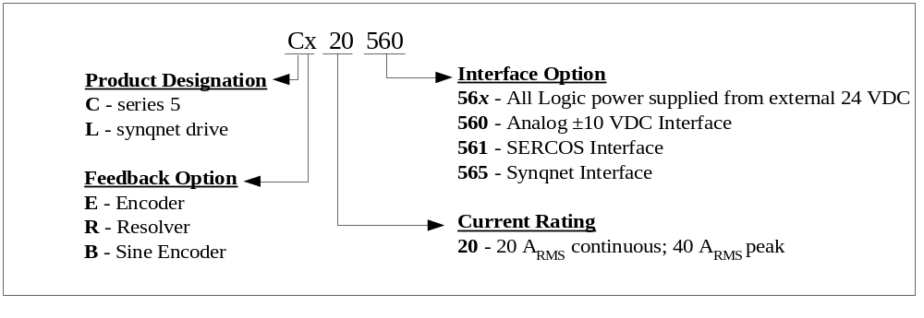
Possible part numbers are:
CE20561 – CD series 5, 20 A_{RMS} continuous, Incremental encoder feedback, SERCOS interface
CR20560 – CD series 5, 20 A_{RMS} continuous, Resolver feedback, Analog Interface
LB20565 – Synqnet Drive, 20 A_{RMS} continuous, sine encoder feedback, Synqnet Interface

Input Power Filtering
The SERVOSTAR CD electronic system components require EMI filtering in the input power leads to meet the conducted emission requirements for the industrial environment. This filtering blocks conducted-type emissions from exiting onto the power lines and provides a barrier for EMI on the power lines.
Be sure to adequately size the system. The type of filter is based on the voltage and current rating of the system the incoming line is three-phase. These filters are mounted as close to the incoming power as possible so noise is not capacitively coupled into other signal leads and cables. These lines may be noisy, so separate them from other sensitive cabling to avoid unwanted coupling of noise. Several manufacturers of these filters are listed below. They should be able to recommend the best filter design for most typical motor control applications. Danaher Motion also provides specific filter recommendations that adequately attenuate the conducted noise to levels well below the CE limits. Implement the EMI filter according to the following guidelines:
— Mount the filter on the same panel as the drive.
— Mount the filter as close as possible to the incoming cabinet power.
— When mounting the filter to the panel, remove any paint or material covering. Use an unpainted metallic back panel, if possible.
— Filters are provided with an earth connection. Tie all ground connections to ground.
— Filters can produce high leakage currents. Earth filters before connecting the supply!
— Do NOT touch filters for 10 seconds after removing the supply.
Recommended EMI Line Filter for CD20
Schaffner FN3258-30-47
http://www.schaffner.com
Schaffner Holding AG
Nordstrasse 11
CH-4542 Luterbach
Switzerland
T +41 32 6816 626
F +41 32 6816 641
CORCOM
http://www.corcom.com
Telephone 847-680-7400
For Customer Service please call 1-800-468-2023
FAX 847-680-8169
Postal address 844 E. Rockland Road
Libertyville, Illinois 60048
Fair-Rite
http://www.fair-rite.com
Telephone (888) FAIRRITE (324-7748) or (845)895-2055
FAX (888) FERRITE (337-7483) or (845) 895-2629
Postal address PO Box J, 1 Commercial Row
Wallkill, NY 12589

Outline Dimensions
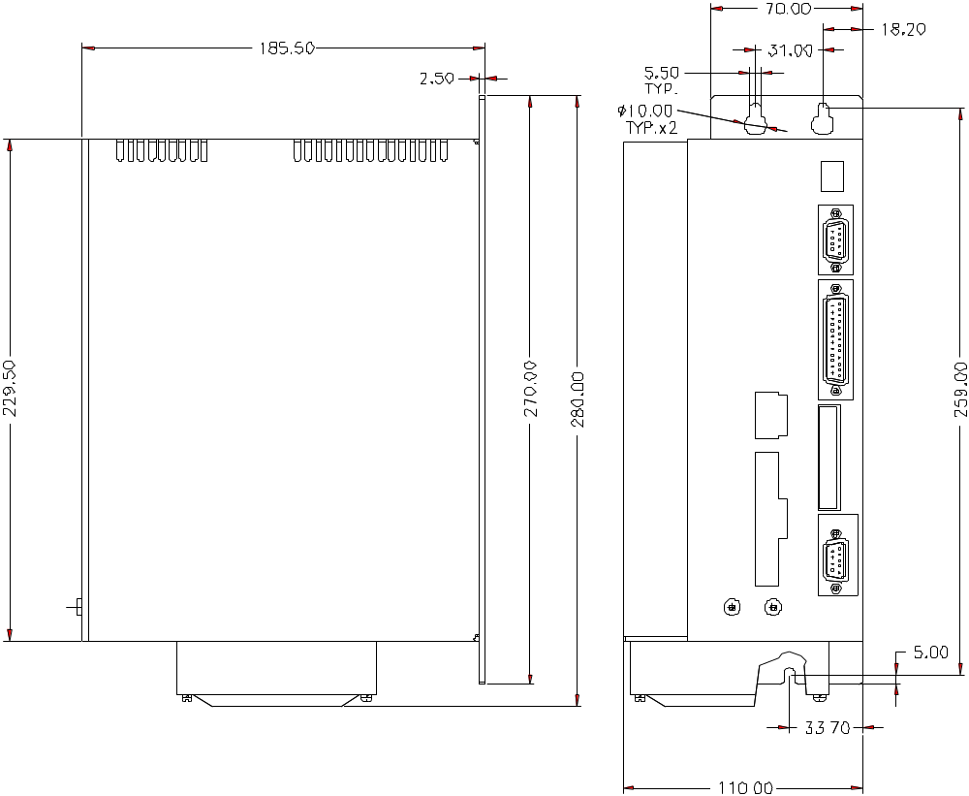

Cx20 System Wiring

(CD Series 5)
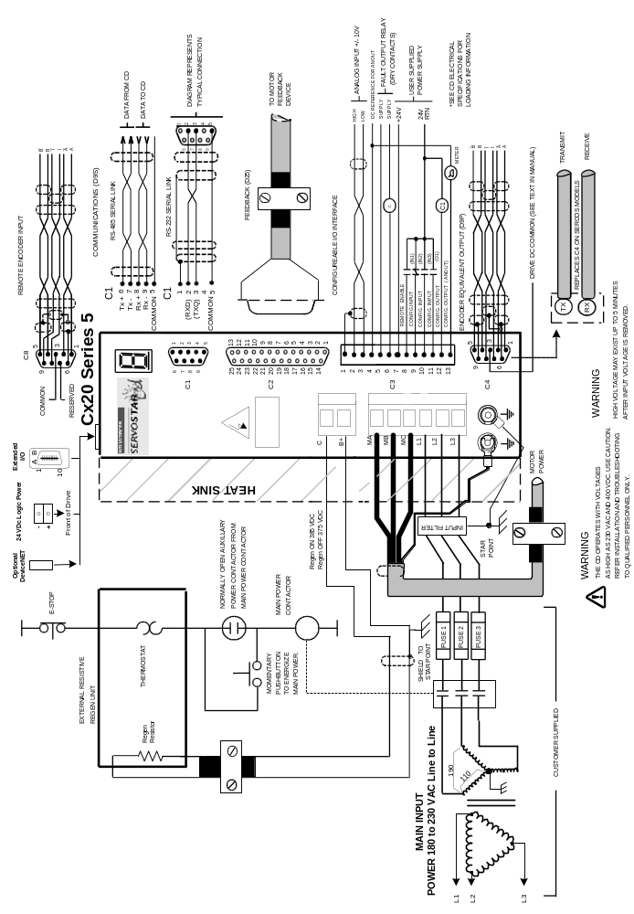

Cx20 (Cx2056y)
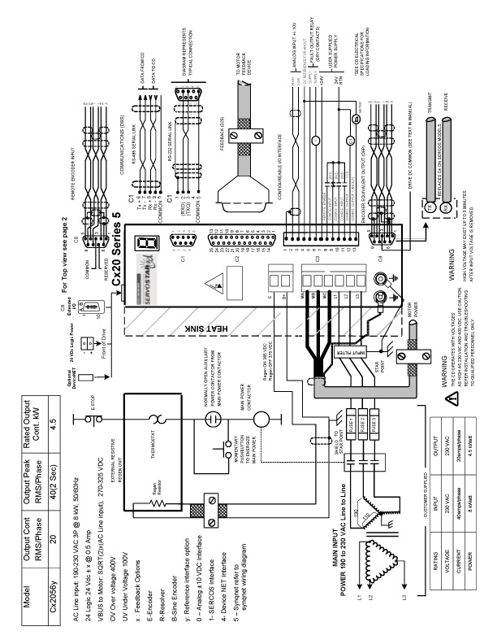

Lx20 (Synqnet)
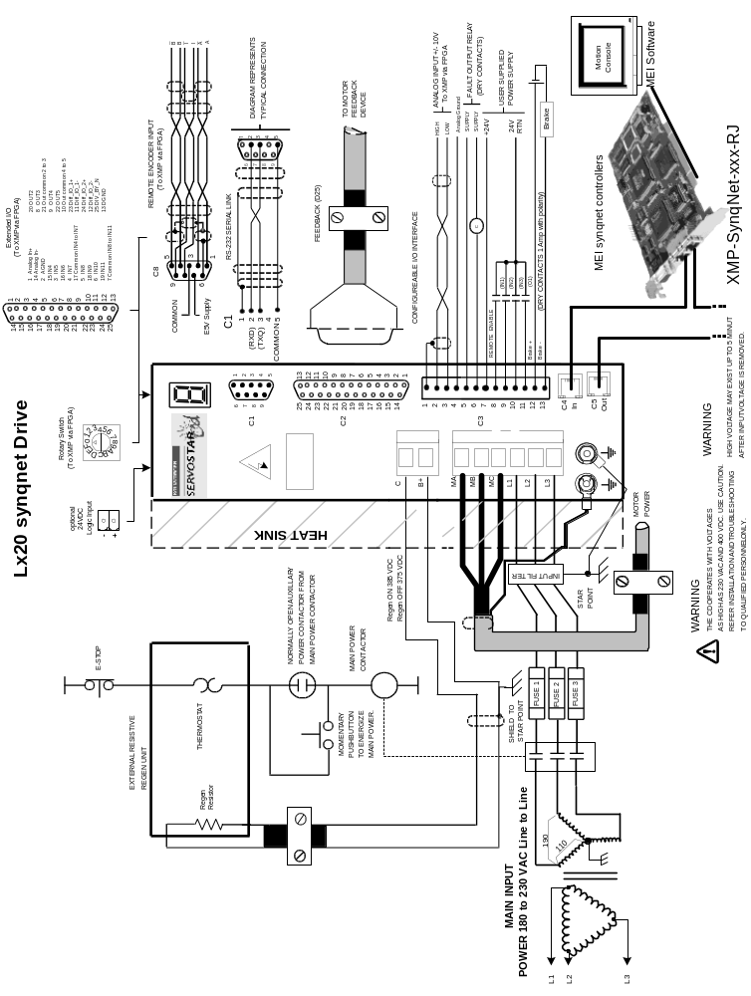

Hardware Specifications
Amplifier Model |  | Cx20
Unit Weight | Lbs./Kgs. | 8.8 / 4
Mounting  Hardware | English (Metric) | 10-32 (M4)
Mounting  Hardware | Applied Torque | 20 lb-in. (2.26 N-m.)
Connection  Hardware | Line Screw Size/Torque | M3.5/12 lb-in. (1.35 N-m)
Connection  Hardware | BUS Screw Size/Torque | M3.5/12 lb-in. (1.35 N-m)
Connection  Hardware | Motor Screw Size/Torque | M3.5/12 lb-in. (1.35 N-m)
Connection  Hardware | Ground Screw Size/Torque | M3.5/12 lb-in. (1.35 N-m)
Wire Size  (AWG#) | Control Logic (AWG/ mm²) | 16 / 1.31
Wire Size  (AWG#) | Configurable I/O wire gauge | 22-18 AWG (0.3-0.75 mm²) Ferrules recommended:  18 AWG Type H0 - 75/14 Weidmuller 4629.0 or equivalent  20 AWG Type H0 - 5/14 Weidmuller 6907.0 or equivalent  22 AWG Type H0 – 34/12 Weidmuller 90257.7 or equivalent
Wire Size  (AWG#) | Regen (AWG/ mm²) C B+ | 10 / 5.26
Wire Size  (AWG#) | Motor Line (AWG/ mm²)  Main Input Ma Mb Mc L1 L2 L3 | 10 / 5.26
Clearance  Distance | Side-to-Side | 0.5 in (12.7 mm)
Clearance  Distance | Top/Bottom | 2.5 in (63.5 mm)
Mating  Connector  Hardware | CK100 Kit | Includes: C1, C2, C4, C7 (plus 2 ft./0.69 m.  of stranded bus ribbon), C8
Mating  Connector  Hardware | C1 | D9 Female  EDA 8S0009SS402S25 Connector 9 pins D type for Cable solder
Mating  Connector  Hardware | C2 | D25 Male  EDA 8S0025SS402525 Connector 25 pins D Type  For Cable solder
Mating  Connector  Hardware | C3 | Danaher Motion #: A-93899-013  Vendor Info: Weidmuller BL3.5/13 Cat.No. 161574
Mating  Connector  Hardware | Connector Screw Torque | 2.25 lb-in. (0.25 N-m)
Mating  Connector  Hardware | C4 | D9 male or Sercos or RJ45 for synqnet  EDA 8S0009SS402S25 Connector 9 pins D type for Cable solder  Sercos matting connector come w/ the sercos cable  RJ45 shielded Ethernet cable
Mating  Connector  Hardware | C7 | 10 Pin (0.1”x0.1”) Female ribbon
Mating  Connector  Hardware | C8 | D9 male  EDA 8S0009SS402S25 Connector 9 pins D type for Cable solder
Mating  Connector  Hardware | C9 | 20 PIN connector  HIROSE FX2BA-20SA-1.27R
Mating  Connector  Hardware | Regen (AWG/ mm²)  C B+ | Connector: 2 x PIN Molex MiniFit Molex P/N 42816-0212  *Terminal (Pins): Molex P/N 42815-0031
Mating  Connector  Hardware | Motor Line (AWG/ mm²)  Main Input Ma Mb Mc L1 L2 L3 | Connector: 6 x PIN Molex MiniFit Molex P/N 42816-0612  *Terminal (Pins): Molex P/N 42815-0031
Mating  Connector  Hardware | 24 V Logic (optional) | Danaher Motion #:A-81014-002 Vendor Info: PCD ELFP02210
* Molex Crimp tooling P/N 63811-1500 for terminal pins

Electrical Specifications
Product Model |  | Cx20
Main Input Power | Voltage (VAC_{L-L}) Nominal ±10% | 180 to 230 3φ only
Main Input Power | Line Frequency Hz | 47-63
Main Input Power | Input power at 180 VAC L-L | 5.3 kW
Main Input Power | Input power at 208 VAC L-L | 6.2 kW
Main Input Power | Input power at 230 VAC L-L | 6.8 kW
Main Input Power | Continuous Current (A) | 20 A/phase
Main Input Power | Peak Current (A) for 2s | 40 A/phase
Main Input Power | Line Fuses (FRN-R, LPN, or equiv.) | 25
Logic Input Power | +24 VDC Ext. Logic Voltage (V) | 22 to 27
Logic Input Power | +24 VDC Ext. Logic Current (amps sink) | 1.5
Logic Input Power | +24 VCD Ext. Logic Current (amps max surge) | 2.6
SoftStart | Max. Surge Current (A) | 200
SoftStart | Max. Charge Time (msec) | 50
Protection Functions | Fault Contact Rating (A) | 1
Protection Functions | Fault Contact Closing Period (ms) | Close = 3 ms, Open = 2 ms
Protection Functions | Over-Temperature Trip (°C/°F) | 80/176
Rated Main Output  (Ma, Mb, Mc) | Continuous Power at 180 VAC L-L  Line Input (45°C (113°F) Ambient) | 4 kW
Rated Main Output  (Ma, Mb, Mc) | Continuous Power at 230 VAC L-L  Line Input (45°C (113°F) Ambient) | 5.2 kW
Rated Main Output  (Ma, Mb, Mc) | Continuous Current (A_{RMS}) | 20
Rated Main Output  (Ma, Mb, Mc) | Peak Current (Arms) for 2 sec | 40
Rated Main Output  (Ma, Mb, Mc) | PWM Frequency (kHz) | 8
Rated Main Output  (Ma, Mb, Mc) | PWM Motor Current Ripple (kHz) | 16
Rated Main Output  (Ma, Mb, Mc) | Form Factor (rms/avg) | ≤1.01
Protective Functions | Under-Voltage Trip (nominal) (VDC) | 100
Protective Functions | Over-Voltage Trip (VDC) | 400
Protective Functions | Over-Temperature Trip (°C/°F) | 80/176
Protective Functions | Internal heat dissipation (watts) | 330
Environment | Operation temperature (°C/°F) | 5/41 to 45/113
Environment | Storage temperature (°C/°F) | 0/32 to 70/158
Environment | Ambient humidity (%) | 10 to 90
Environment | Atmosphere | without corrosive gasses or dust
Environment | Altitude | Derate 5% per 1000 ft.(300 m)  above 3300 ft. (1000 m)
Environment | Vibration (g) | 0.5
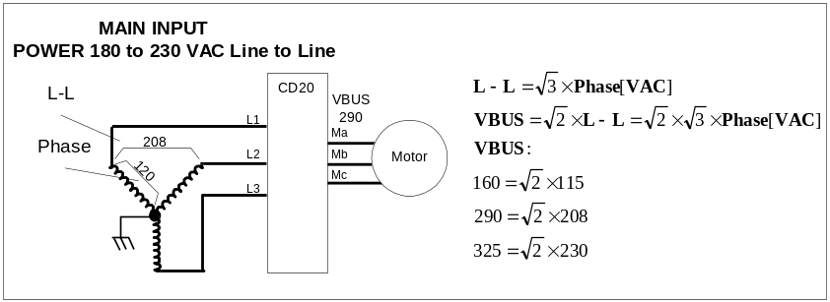

Regen Information
Product Model |  | Cx20
External Shunt Regulator | Peak current (amps) |  | 45
External Shunt Regulator | Minimum resistance (ohms) |  | 4 at 190VBUS / 8 at 320VBUS
External Shunt Regulator | watts |  | 1 kW
External Shunt Regulator | BUS Voltage (nominal) (VDC) |  | 325
External Shunt Regulator | V_{HYS} (Regen circuit turn-off) (VDC) |  | 375
External Shunt Regulator | V_{MAX} (Regen circuit turn-on) (VDC) |  | 385
External Regen Kits | TBD |  |  |  |  | 

CD20 Series 5 TOP View
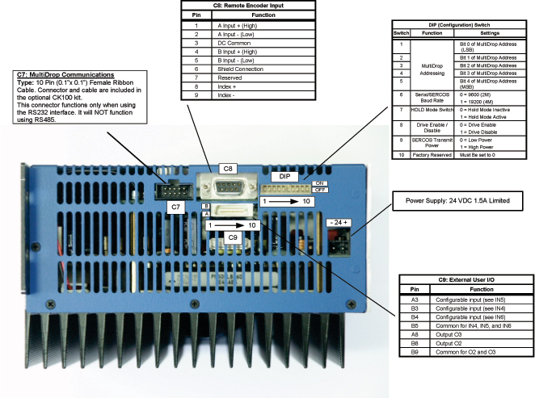

CD20 Series 5 Mating Connectors
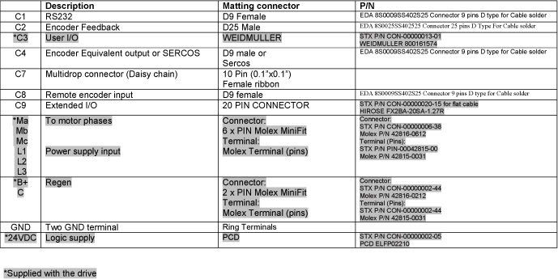

Customer Support
Danaher Motion products are available world-wide through an extensive authorized distributor network. These distributors offer literature, technical assistance, and a wide range of models off the shelf for the fastest possible delivery.
Danaher Motion sales engineers are conveniently located to provide prompt attention to customer needs. Call the nearest office for ordering and application information and assistance or for the address of the closest authorized distributor. If you do not know who your sales representative is, contact us at:
Danaher Motion
203A West Rock Road
Radford, VA 24141 USA
Phone: 1-540-633-3400
Fax: 1-540-639-4162
Email: customer.support@danahermotion.com
Website: www.DanaherMotion.com

