Kollmorgen Automation Suite

Application

Simulated Rotary Knife
2 axes with:
FFLD programming language and PLCopen Motion Engine

(Version 2)

Revision History

Version # | Date | Description
1 | Jan 2, 2014 | Initial Release
2
3
4

Table of Contents
1 Table of Contents 4
2 Introduction 5
2.1 Machine Overview 5
2.2 Registration Control Overview 6
2.3 Project Picture 8
3 User Interface 8
3.1 M1_Panel 8
3.2 M1_PanelStatus 10
4 Setup 11
4.1 User Units 11
4.2 Defines 13
4.2.1 Purpose 13
4.2.2 Status Mask 13
4.2.3 Machine States and Timers 15
4.3 Ethercat Setup 15
4.3.1 Scanning 15
4.3.2 Drive Setup 15
5 Machine Operation 17
5.1 Operation Modes 17
5.2 Start up and Standby Machine State 17
5.3 Manual Operation 17
5.4 Automatic Operation 18
6 Program Code 20
6.1 Main 20
6.2 Mode Controller 20
6.3 Standby Mode 22
6.4 Manual Mode 22
6.5 Automatic Mode 24
6.6 Error Stop Mode 26
6.7 Error Fatal Mode 26

Introduction

Machine Overview
This document details a KAS 2 axis simulated rotary knife application with virtual master and registration operation.
The axes are as follows:

- Axis 1: Feed Conveyor
- Axis 2: Rotary Knife
- Axis 3: Virtual Master (Simulated)

The following mechanics was used to create the simulated rotary knife application:

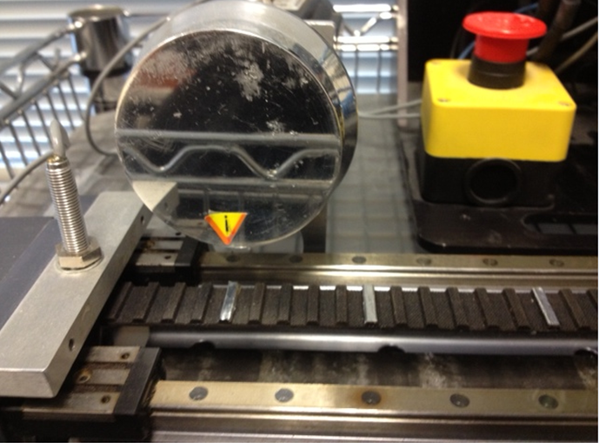
Axis 2: Simulated Rotary Knife
Axis 1: Feed Conveyor
Sensor
Registration Marks

The application demonstrates the KAS controller’s ability to perform registration in a rotary knife type application.

The application is run using the internal KAS IDE Control Panel screens:

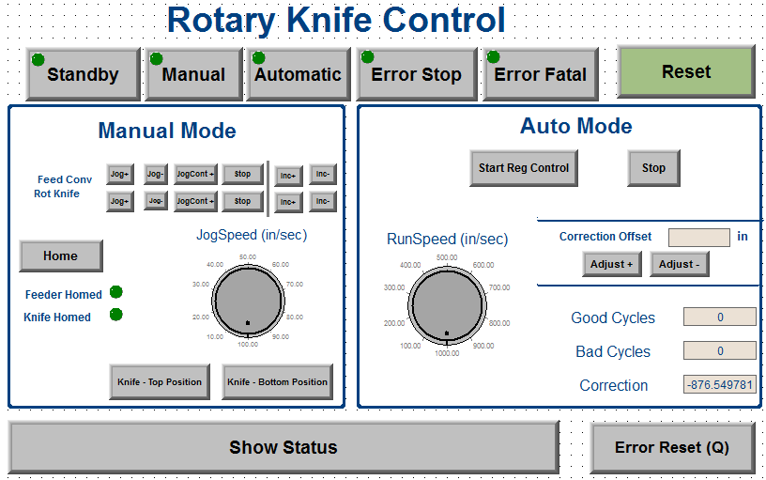

Registration Control Overview
- The Kollmorgen MC_MachRegist and the MC_MoveSuperimp function blocks to implement registration

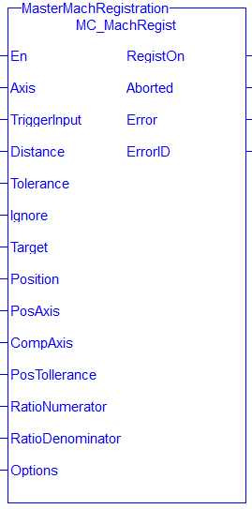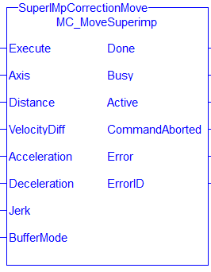

Project Overview
Below is the KAS IDE Project Explorer view of the application:

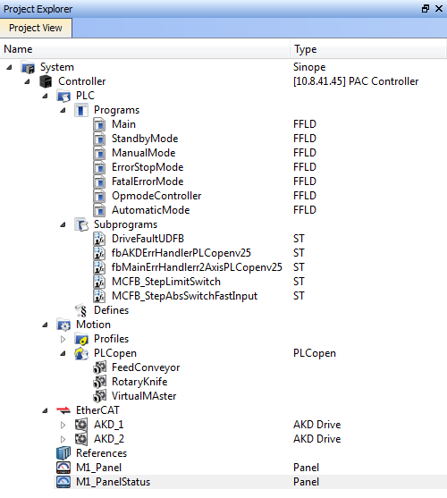
PLC programs and subroutines
Servo Axes
Ethercat Network, Drive configuration and commissioning
Internal Control Panel used to run the application and for troubleshooting

User Interface

M1_Panel
There are 2 Control Panels in this project as highlighted below:

These screens allow the users to operate the machine, there are 5 operating modes:

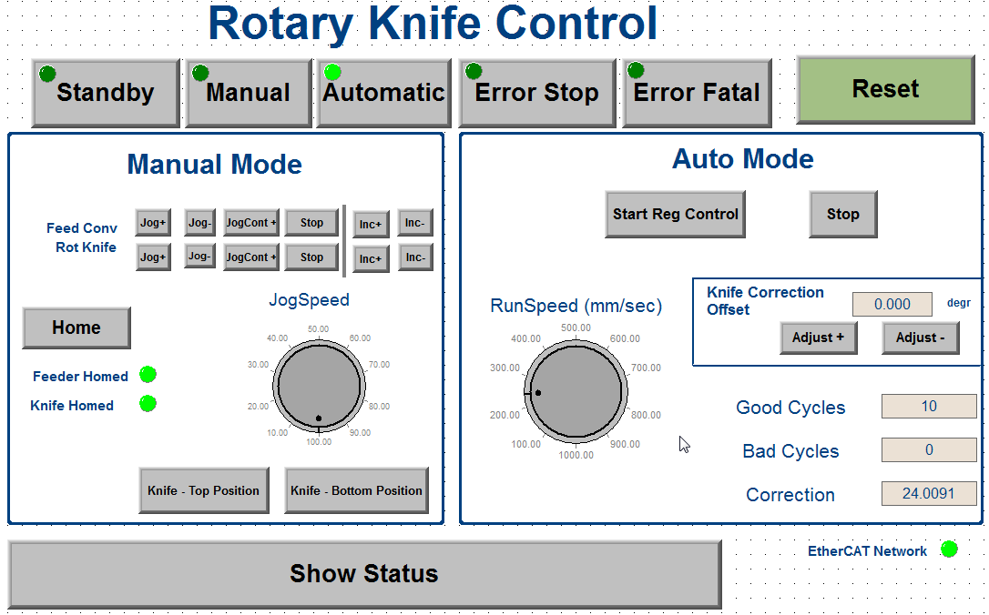

M1_PanelStatus
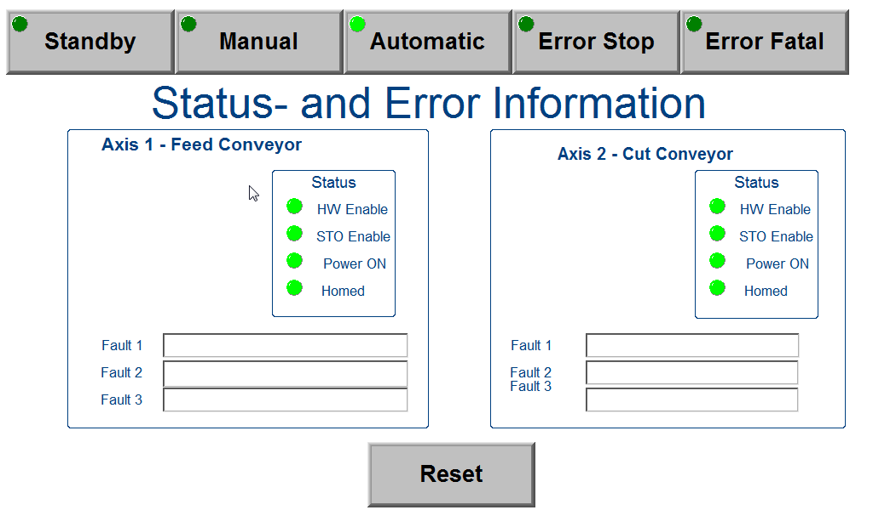

Setup

User Units

Below is a summary of the user units used in the application. The virtual master, left winder and right winder have base units of degrees/sec. The draw roller and die cutter have base units of mm/sec. For the draw roller and die cutter the User Units (UU) per turn are calculated incorporating the diameters of the drive rollers. Note: DU = Drive Units

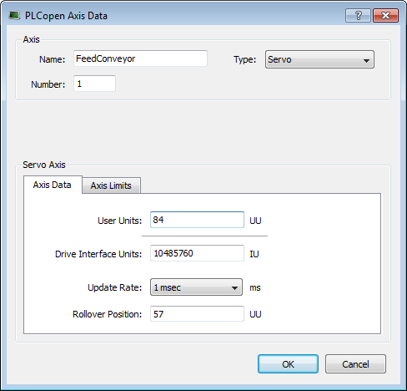

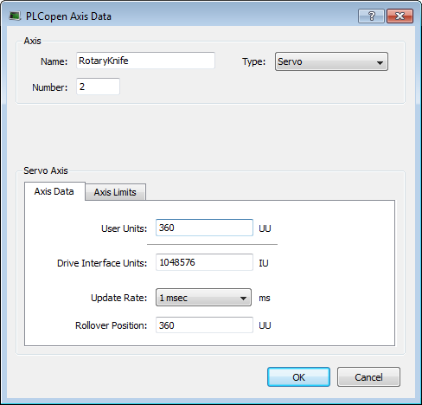

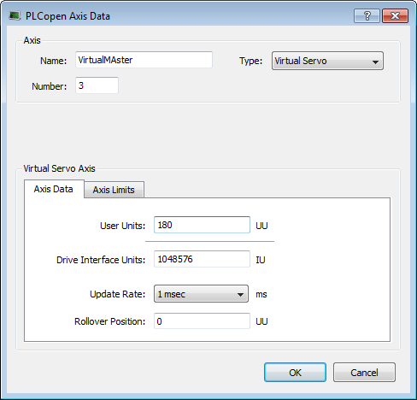

Axis | Gear Ratio | DU per rev | User Units | UU per (motor) Rev | Axis Rollover
1 Feed Conveyor | 2 | 1048576 | mm | 8.4 mm | 57
2 Rotary Knife | N/A | 1048576 | degrees | 360 Degrees | 360
3 Virtual | N/A | 1048576 | degrees | 360 Degrees | 180

DD = Drive Units
UU = User Units

Defines

Purpose
In the project tree the Defines section contains value for project parameters to configure the project for a particular machine mechanics and desired machine performance. With Defines, the KAS application program can be tailored for a variety of machine types.

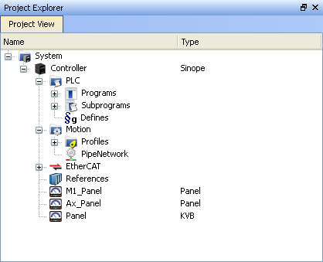

Defines can be used as compiler directives and set up the application for individual machine needs including for the following:

- Machine Mechanics
- M1 (Main) status masks – sets up bits in the Machine status word
- Ax (Axis) status masks – set up definition for bits in the Axis Status Words
- M1 (Main) initialization – virtual axis motion setup
- Machine states – sets up the machine states used in the application
- System timers
- IO mapping

Status Mask
Status mask are used to setup the bit definitions of the Axis and Machine Status Words: A1_StatusWord, A2_StatusWord, and M1_StatusWord. Example: The bit masks for the axis status word are:

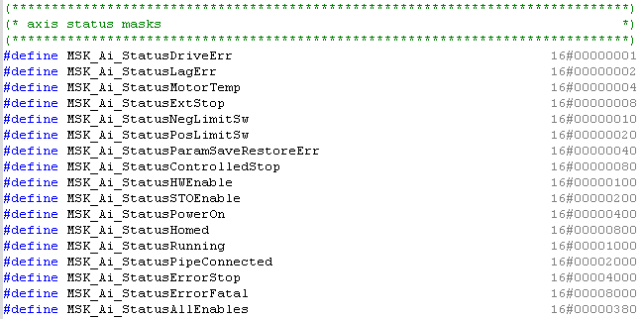

Status Masks are also used to set how the fault handler shuts down when certain fault conditions occur:

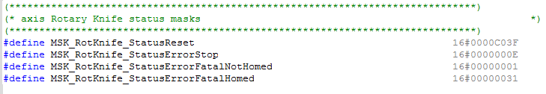

For example:

MSK_RotKnife_StatusReset = 16#0000C03F. Looking at the axis status mask definitions this means the user can reset the following conditions: bits 1(LagError),bit 2(Motor Temp Error), bit 3(External Stop), bit 4(Neg Limit Switch), bit 5(Pos Limit Switch), bit 14(Error Stop), and bit 15(Error Fatal).

MSK_RotKnife_StatusErrorStop = 16#000000E. Looking at the axis status mask definitions this means that the control will go into a Error Stop mode when one of the following occurs:
bits 0(DriveErr), bit 1(LagError),bit 2(Motor Temp Error), bit 3(External Stop). All other bits will cause the control to go into Error Fatal mode.

MSK_RotKnife_StatusErrorFatalNotHomed = 16#0000001. Looking at the axis status mask definitions this means that the control will go into a Error Fatal mode if the axis is not homed and the follow conditions occur: bit 1(Lag Error)

MSK_RotKnife_StatusErrorFatalNotHomed = 16#0000031. Looking at the axis status mask definitions this means that the control will go into a Error Fatal mode if the axis is not homed and the follow conditions occur: bit0 (Drive Error) = bit 1(Lag Error), bit 4(Neg Limit SW), and bit 5(Pos Limit SW).

Machine States and Timers
Defines are used to define Machine State names in the programs and Fault Handler Timer values.
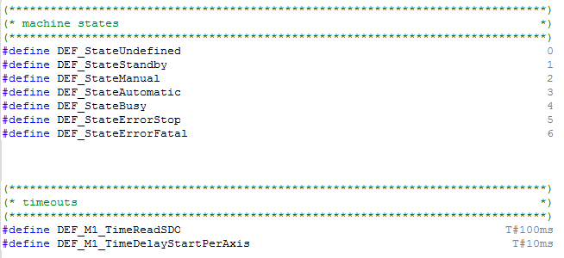

Ethercat Setup

Scanning
The system’s Ethercat network can be configured into the project by using the ‘Scan Devices’ feature once the controller has been connected to the items (drives and remote I/O) on the network.
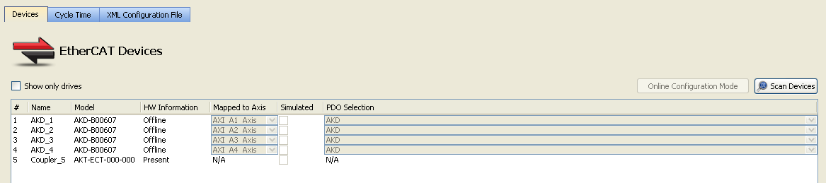

Drive Setup
The commissioning of each drive can be accomplished by opening the AKD item. Once this is open each drive can be configured for line voltage, the motor and load including tuning, system limitations and the parameters. The available screens embedded in the KAS IDE are similar, although not all the same, as the AKD Workbench screens.

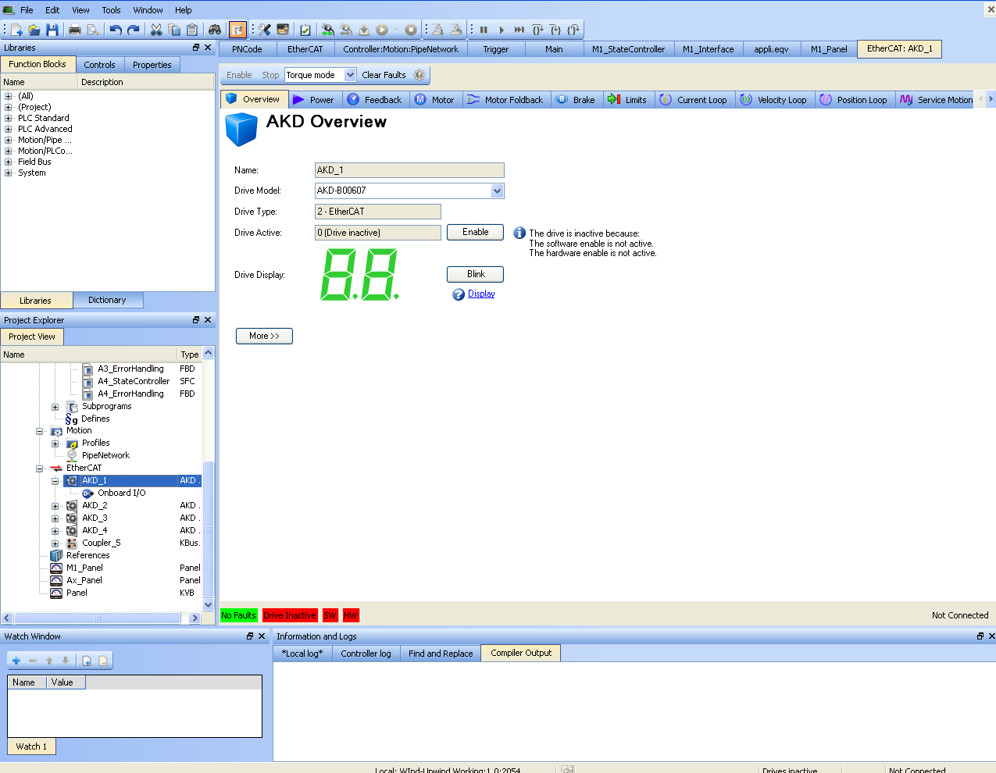

Machine Operation

Operation Modes
The buttons on the top can be pressed to place the machine in various operation modes:

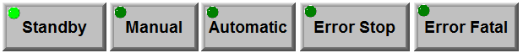

ErrorStop or ErrorFatal mode is automatically entered when an error occurs. When the error is cleared then the system will automatically go back to the previous mode before the error occurred. The present mode that the machine is in is indicated by the lighted LED on the button.
Summary of the modes is as follows:
State | Description
Standby | No faults, drives not enabled
Manual | No Faults, Manual Jog operation
Automatic | No Faults, Multi-axis machine operation
Error Stop | Fault state, not a fatal fault
Error Fatal | Fault state, fatal fault(s)

Start up and Standby Machine State
The machine powers up in standby mode:


Manual Operation
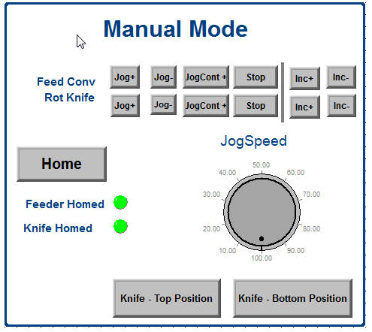

In Manual mode the motors can be homed, jogged or moved incrementally. Additionally during setup the rotary knife can be moved to either the top (zero degree) or bottom (180 degree) positions by clicking on the appropriate button.

Automatic Operation
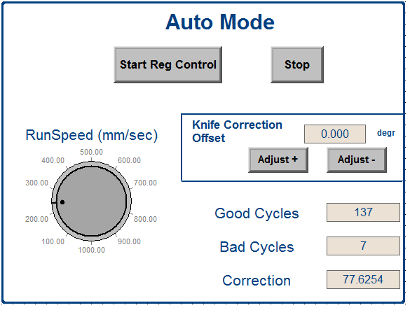

Before operating in Automatic Mode an initial homing of the 2 axis is required in Manual Mode.

In Automatic mode, the operation speed can be set, registration control can be turned on or off, the registration correction distance can be offset, and the number of good cycles, bad cycles, and last registration correction amount is displayed.

Program Code
This project contains the following program:
.
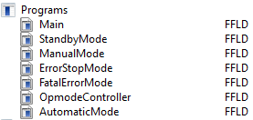

Functionality is as follows:
Program | Description
Main | Executes motion engine initialization and start up, reads drive information, closed servo loops to enable the drives and call error handler UDFBs
Opmode Controller | Controls which opmode will be active
Manual Mode | Performs jogging and homing
Automatic Mode | Performs full machine operation with registration control
Error Stop Mode | Performs a controlled stop of motion and stays in this mode until the error is cleared
Fatal Error Mode | Disables drive immediately stays in this mode until the error is cleared

Main
Program Type: FFLD
The Main Program performs the following:

- Initializes and start up the Motion Engine
- Assign axis names to axis numbers
- Extend Error Reset for Error Handling Routine
- Open and close servo loops
- Read Axis Status
- Read Drive Faults
- Read Axis Position
- Read Motion Engine Status
- Execute axis and machine level error handling UDFBs
- Reads last Drive Errors by calling DriveFaultUDFB

Mode Controller
Program Type: FFLD
The Mode Controller Program controls the state or operation mode of the application. The following states are supported:
State | Description
Standby | No faults, drives not enabled
Manual | No Faults, Manual Jog operation
Automatic | No Faults, Multi-axis machine operation
Error Stop | Fault state, not a fatal fault
Error Fatal | Fault state, fatal fault(s)

. On application start-up, the state machine goes into the Standby mode. The op mode is then changed to one of the following ways:
- An opmode change is requested from the internal control panel. The variable bM1_Manual request the manual opmode for example. The Mode Controller program then sets the parameter M1_ReqState to the requested mode.
//*********************************************
//** State Defines
//*********************************************
#define DEF_StateUndefined 0
#define DEF_StateStandby 1
#define DEF_StateManual 2
#define DEF_StateAutomatic 3
#define DEF_StateBusy 4
#define DEF_StateErrorStop 5
#define DEF_StateErrorFatal 6.

- An opmode is automatically changed when an error occurs or an error is cleared. An error is cleared by clicking on the Reset button in the control panel. After the error condition is cleared, clicking on the reset button in the internal Control Panel or Kollmorgen AKI will send M1_ReqState will be set back to the previous state (typically Manual or Automatic Mode).

At the top of each program (StandbyMode, ManualMode, AutomaticMode, ErrorStopMode, and FatalErrorMode) there is code to read the value of M1_ReqState and only execute code in that program is M1_ReqState is set for that mode. As an example, here is the code at the top of the AutomaticMode program

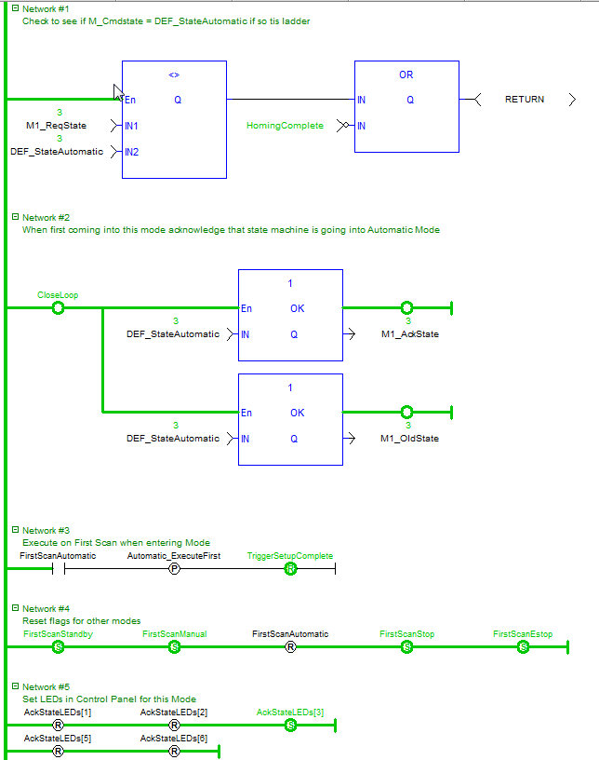

Standby Mode
Program Type: FFLD
The Manual Mode Program performs the following:

- Stops any ongoing motion when first entering this mode
- Disables the drives

Manual Mode
Program Type: FFLD
The Manual Mode Program performs the following:

- Halts any ongoing motion when first entering this mode
- Stop Registration
- Jogging each axis individually
- Home the axes (calls DriveFaultUDFB)
- Perform relative or absolute motion individually on each axis

The home position is as follows:
- RotaryKnife Axis: top bottom center, rotary position
- Feeder Axis: Cut position for first work piece

To home the Feeder Axis the MC_Reference function block is used:
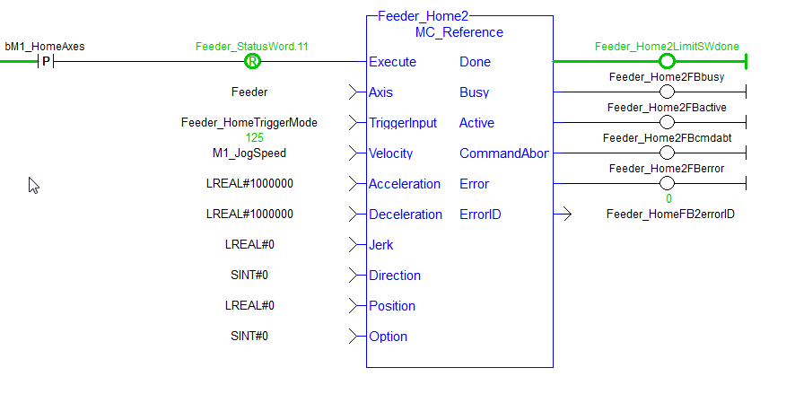

After hoimg an offset move is made and then the starting home position is established:

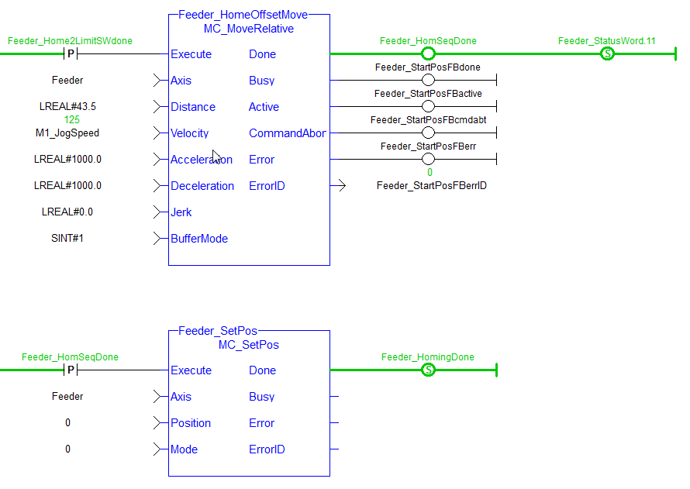

To home the Rotary Knife Axis a second homing function block was use, the MCFB_StepAbsSwitchFastInput function block. Note: The MC_Reference could have also been used:

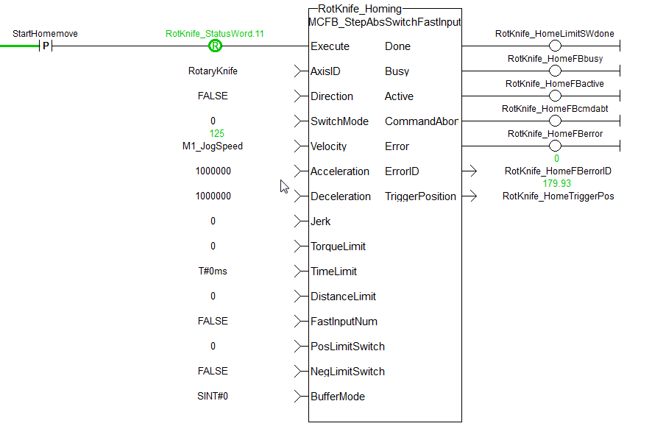

After hoimg an offset move is made and then the starting home position is established:

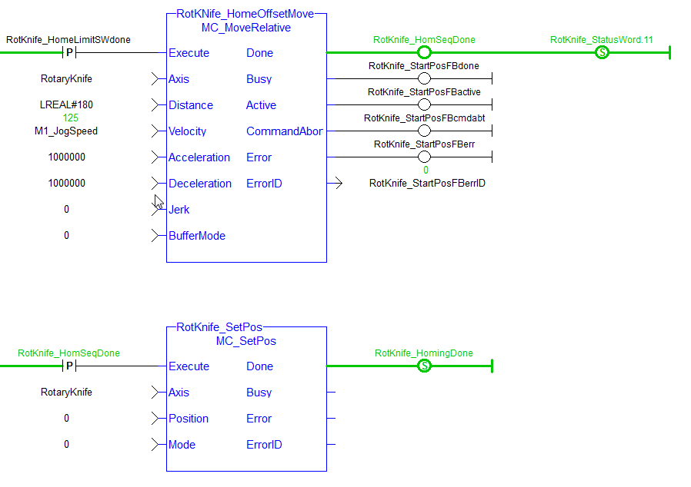

Automatic Mode
Program Type: FFLD
The Automatic Mode Program performs the following:
- Setup High speed position capture configuration
- Setup Gearing of Feeder and Rotary Knife Axes to Virtual Master Axis
- Setup Registration (Mark to Machine)
- Get Registration status – valid mark, good mark distance, number of bad marks
- Calculate phase adjustment and make correction

To perform Registration the Rotary and Feeder Axes are slaved to a virtual master axis using the following:

Setup High speed position capture configuration:

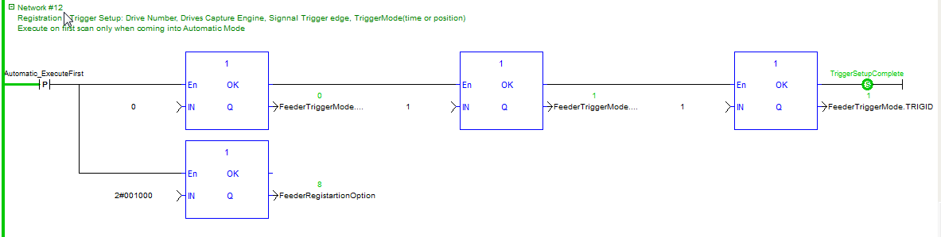

Setup Gearing of Feeder and Rotary Knife Axes to Virtual Master Axis

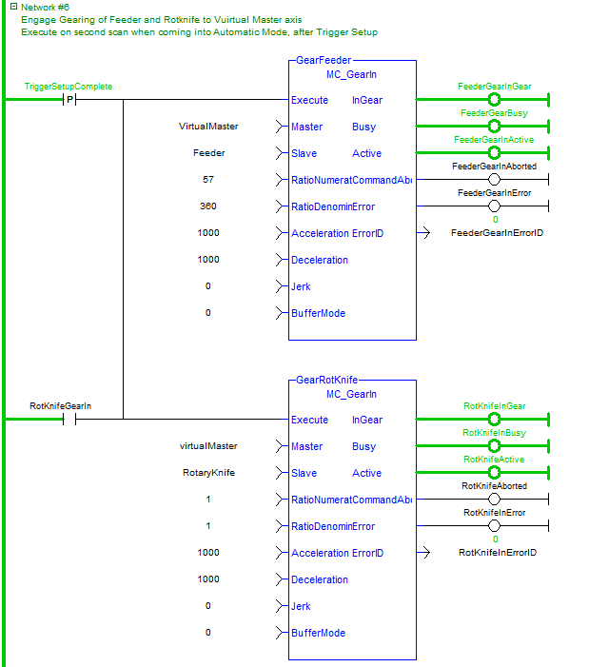

Setup Registration (Mark to Machine):
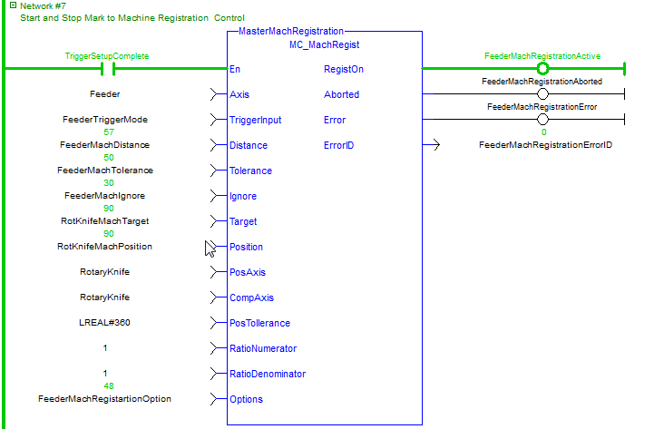

Explanation of several inputs is as follows:
Input | Description
Axis | The registration axis whose position, at the fast input, is used to determine if the mark is a good mark. Since the axis is a slave axis, Slave Registration will be activated. Slave Registration calculates a compensation that is added to the slave offset of the axis. This compensation value is applied directly to the slave axis
TriggerInput | Specifies the Fast input: Capture engine 0 and capture on rising edge. Uses a instance of the library function: TRIGGER_REF
Distance | Expected distance between good marks
Tolerance | Tolerance, plus or minus, to determine if the mark detected by the fast input is a good mark.
Ignore | Distance after the previous good mark in which any detected marks are ignored
Target | Ideal capture position.
Position | Resets the actual position of the registration axis when a good registration mark occurs.
PosAxis | Actual Position of this axis that is captured when the fast input occurs. Target is compared to the Actual Position to calculate the amount of registration compensation to apply
CompAxis | Axis to apply the calculated registration compensation to
Pos Tollerance | Specifies the distance, plus or minus, about the Target position to determine if the position will be accepted and compensation value is calculated and applied.
RatioNumerator | Number of User Units of CompAxis motion for one product cycle. This value is used with RatioDenominator to create a conversion factor for calculating the compensation value when PosAxis and CompAxis are different axes
RatioDenominator | Number of User Units of PosAxis motion for one product cycle. This value is used with RatioNumerator to create a conversion factor for calculating the compensation value when PosAxis and CompAxis are different
Options | 0001H Resetting  0004H Time based capture  0008H Inhibit reference  0010H Inhibit master compensation  0020H Inhibit slave compensation

The position of the feeder axis is used to caculate the registration correction. The correction is made to the feeder axis. Bits 4 and 5 (making a decimal 48) are set for the Options input. These bits call for inhibiting master and slave compensation. This is because the phase correction or compensation is being done by another function block in order to have the future option tro add jerk reduction to the correctiopn motion:

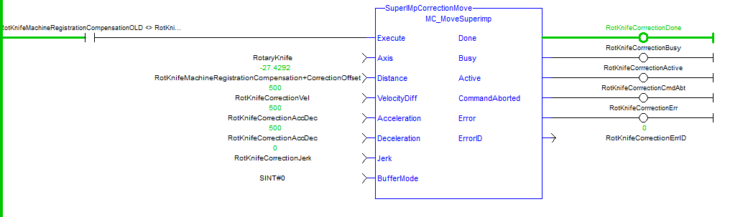

The MC_ReadParam function block is used to get the compensation distance:

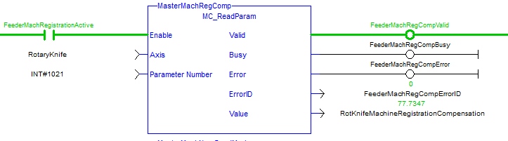

Error Stop Mode
Program Type: FFLD
The Error Stop Program brings motion to a controlled stop when a condition set by the Define parameters occurs. They are:
- #define MSK_RotKnife_StatusErrorStop
- #define MSK_Feeder_StatusErrorStop
- #define MSK_M1_StatusErrorStop

Operation will stay in the Error Stop mode until the error is cleared.

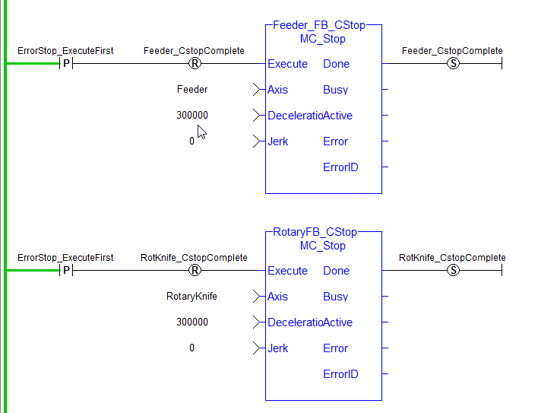

Error Fatal Mode
Program Type: FFLD
The Error Fatal immediately disables the servo drive when a condition set by the Define parameters occurs. They are:
:
- #define MSK_Feeder_StatusErrorFatalNotHomed
- #define MSK_Feeder_StatusErrorFatalHomed
- #define MSK_RotKnife_StatusErrorFatalNotHomed
- #define MSK_RotKnife_StatusErrorFatalHomed
- #define MSK_M1_StatusErrorFatal

Operation will stay in the Error Fatal or Error Stop mode until the error is cleared
