KAS TBot Control
Dec 2019

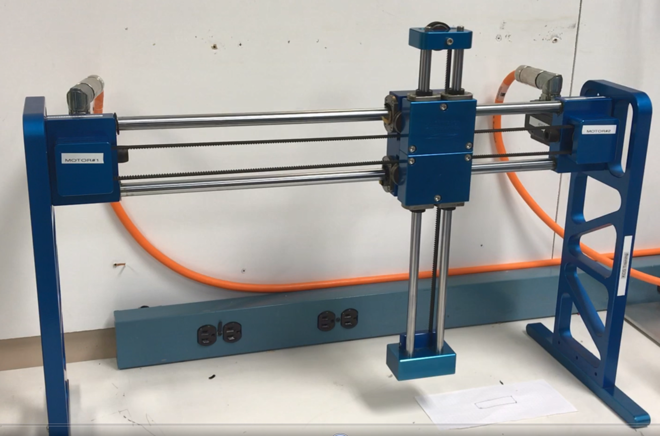

Introduction
This application note details using the KAS PxMM multi-axis controller to control a 2 axis TBot mechanism. A TBot performs 2 axis control through a mechanism ( a single belt with fixed pulleys that drives both axes). The TBot creates full motion within a 2 dimensional envelope.
The application was created by first starting out with the following template:
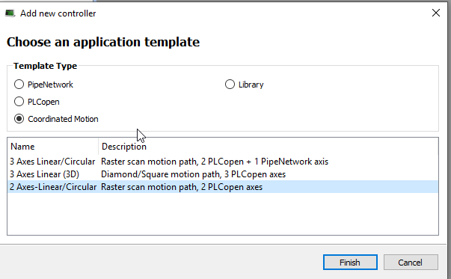

Code was then added and removed as needed to create the 2 axis TBOT control.
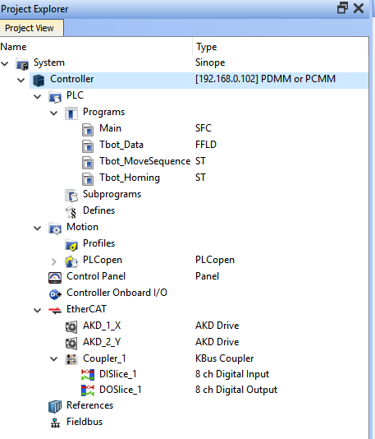
Control Panel Modified
New Programs Added
Key Code That Was Added
Setup MCS Coordinate system (added to the Main Program Step 6)
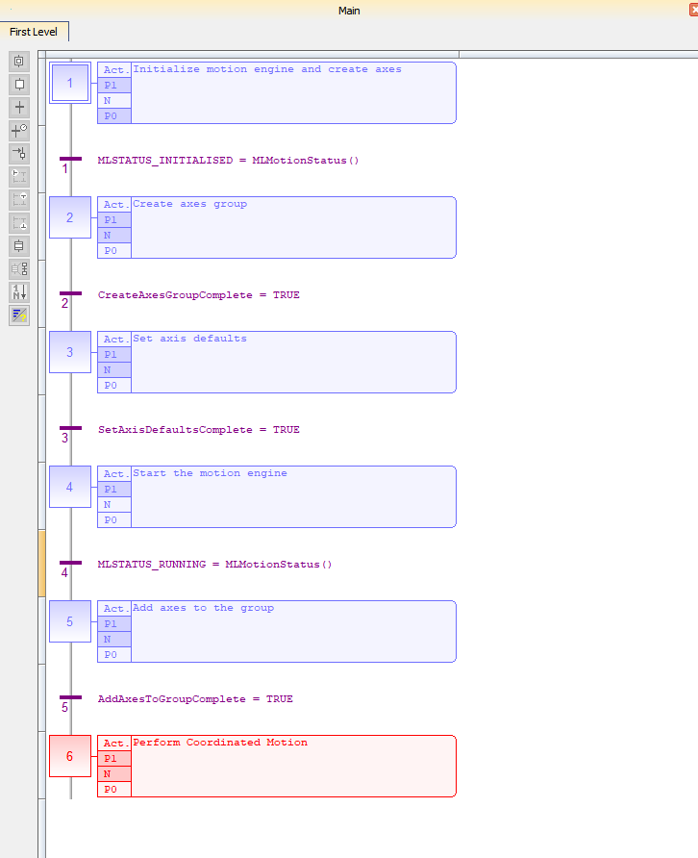

The TBot mechanism utilizes the MCS (Machine Coordinate System) as oppose to the ACS (Axis Coordinate System) that KAS usually employs. The MC_Kin_Ref Structure: (http://webhelp.kollmorgen.com/kas3.03/Content/11.TechRefs/CoordinatedMotion/MC_Kin_Ref.htm?Highlight=Tbot ) defines the TBot robotic system transform and the Function MC_SetKinTra http://webhelp.kollmorgen.com/kas3.03/Content/11.TechRefs/CoordinatedMotion/MC_SetKinTra.htm?Highlight=MC_SetKinTra initiates it:
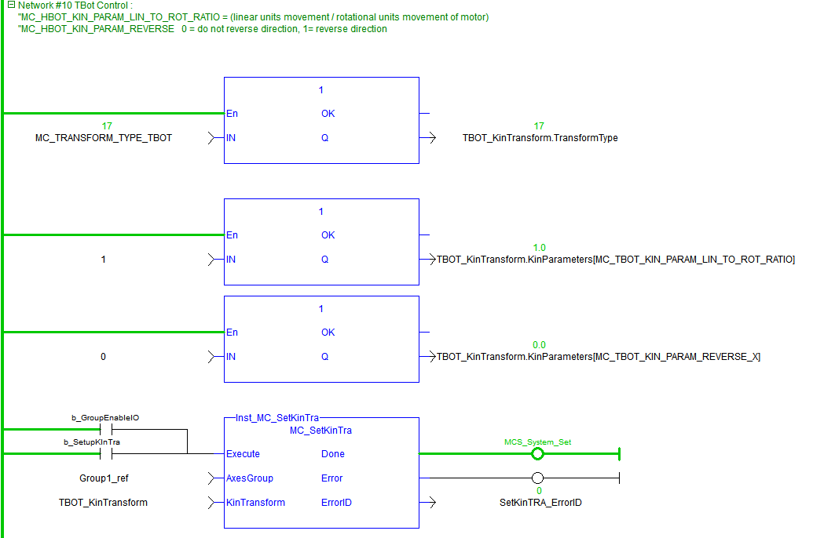

Relative and Absolute Motion
A relative and absolute move were also added to the Man Program. Note the Coord System input is set to 1 for the MC_COORDINATE_SYSTEM_MC. Here is the Function Block for the Relative Move:

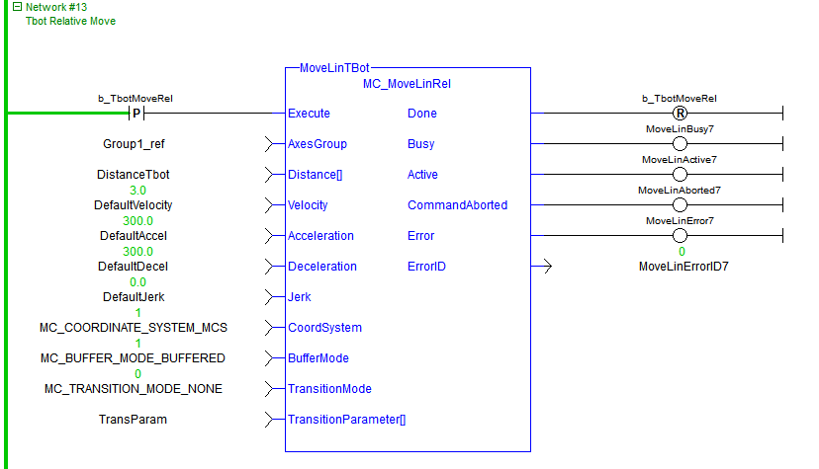

Homing the TBot
The program TBot_Homing was added to home the TBot. Homing consisted of moving to a hard stop (end of travel), first the X axis (horizontal), then the Y axis(vertical). Prior to homing, the max current of the X and Y axis was limited to maintain TBot mechanical integrity. The end of travel was sensed by the position error exceeding a preset value. After both axis physical limits are sensed an offset of 2 inches is made on each axis. At the end of homing the max currents are reset.
Motion Sequence (using Absolute and Circular interpolation)
A new program Tbot_MoveSequence was added that sequences motion through linear and circular interpolation moves.
Sample of the Linear interpolation move

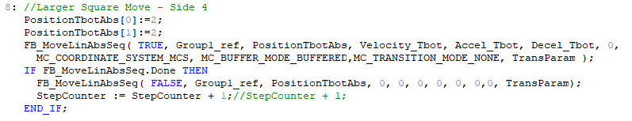
The circular interpolation move makes a complete circle:
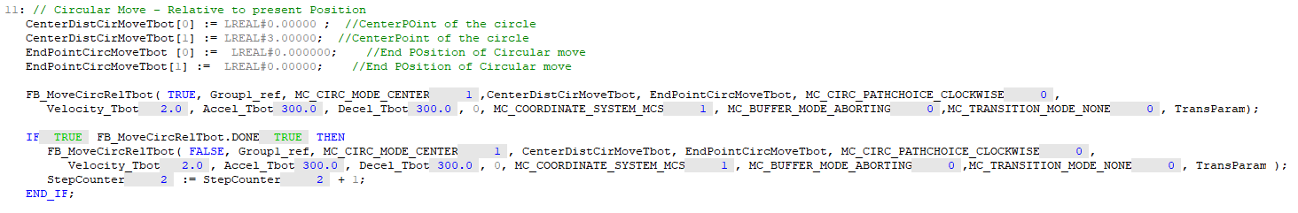

Control Panel
The Control Panel was modified to operate the TBot. The sequence to start motion is:
- Wait for “ECAT Up” LED to turn on after project starts running
- Click on “Group Enable”
- Click on “Set Tbot Kin Transform” button. “At completion, the MCS Coord Set” LED will turn on
- Click on “Home Tbot (Move to Hard Stop)”. At completion, the “Home Hard Stop Method” LED will turn on
- Click on “Start Motion Sequence” button or ether the “Start Absolute Move” button or “Start Relative Move” button to make one move per the Position/Distance inputs. After changing these inputs click the Yellow Set buttons for the new parameters to take affect
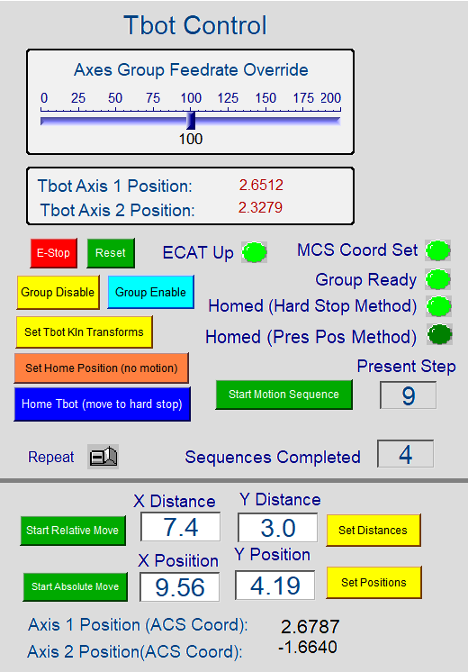

Remote IO Control
An AKT-DNH-000 8 remote Input module and AKT-DT-000 8 remote output module were added to exercise the TBot demo from Remote IO.
- AKT-DNH-000 8 remote input module
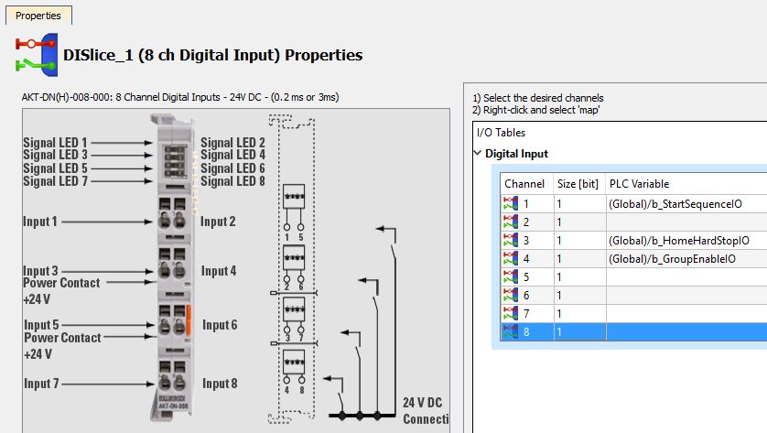
  - b_GroupEnableIO – Enables drives and sets up TBot Kinetic transform
  - b_HomeHardStopIO – Home axis and moves to start position
  - b_StartSequenceIO - Execute Motion Sequence (will repeat sequence when this input remains high
- AKT-DT-000 8 remote output module
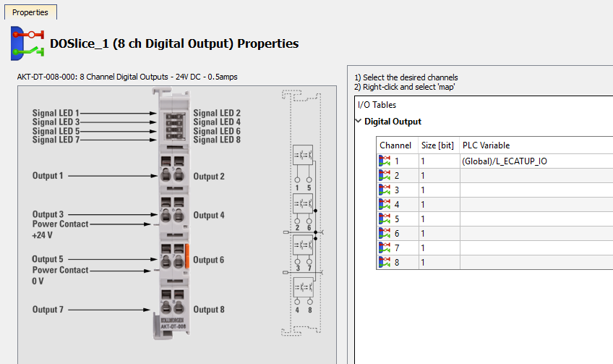
  - b_StartSequenceIO – indicates when ECAT network is up and drives are ready to be enabled

Operation Video
See attachment

