I have a few other suggestions.

You stated your network is simply one Ethernet cable from PC to the AKD drive.
You can press the B1 button on the top of the AKD quickly and the front display of the drive will report the IP address by flashing it.
That way if the drive is setup to not use the rotary switches ( i.e. static IP address ) you can determine what it is.
In the screenshot below note I set my PC IP address to a static address that uses the same first 3 octets of the drive’s IP address ( in this case 192.168.0.x ).
I made sure to set my PC’s IP address to the same convention ( 192.168.0.x ) but with the final octet set to something unique for both the PC and the drive.
On occasion I’ve had to check the checkbox “Specify Address” and manually input the target drive IP address in the case the drive doesn’t show up under the “Workbench has found the following devices.” list.
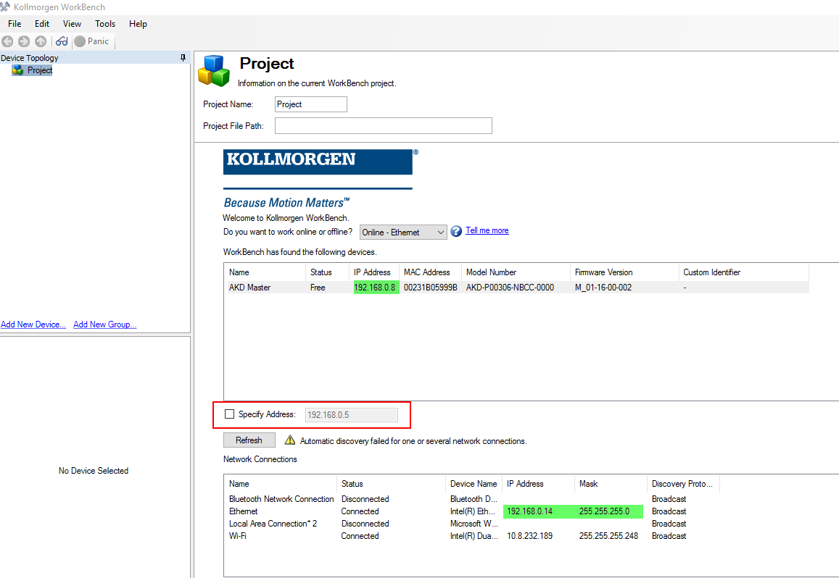

It is important to first ping each IP address ( the PC and the drive ) and ensure there is a reply ( response ).

In Windows, I right click on the bottom left Windows icon and select “Run”

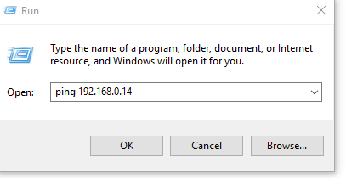

In this case I received replies for my PC.

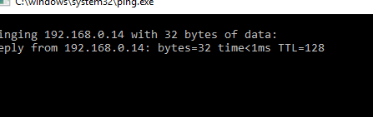

I repeated this test for the drive.

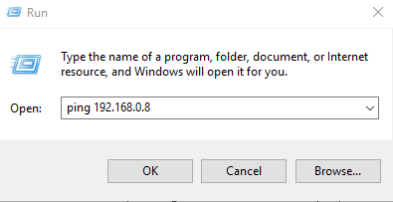
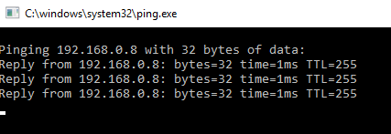

If you can’t ping both devices with successful replies, Workbench has no chance of connecting to the drive.

Let us know if you have more questions or information and we will assist.

