AKT and AKT2G Comparison
Topic |  | AKT | AKT2G
Module Coverage
- Ethercat Coupler |  | AKT-ECT-000-000 | AKT2G-ECT-000-000
- Digital Inputs |  | 4 channel (AKT-DN-004-000)  4 channel high speed(AKT-DNH-004-000)  8 channel (AKT-DN-008-000)  8 channel high speed(AKT-DNH-008-000) | 8 channel (AKT2G- DN-008-0000)  8 channel high speed (AKT2G- DNH-008-0000)
- Digital Outputs |  | 4 channel (AKT-DT-004-000)  8 channel (AKT-DT-008-000)  2 channel relay (AKT-DT-2RT-000) | 8 channel (AKT2G- DT-008-000)
- Thermocouple Input |  | 2 channel (AKT-AN-200-000)  4 channel (AKT-AN-400-000) | 4 channel (AKT2G-AN-400-000)
- PT100 (RTD) Input for resistive sensors |  | None | 2 channel, 3-wire system(AKT2G-AN-240-000)
- Analog Inputs |  | 4 channel 0 – 10 vdc (AKT-AN-410-000)  4 channel 0 – 20mA (AKT-AN-420-000)  8 channel 0 – 10 vdc (AKT-AN-810-000)  8 channel 0 – 20mA (AKT-AN-820-000) | 4 channel parameterizable - covering -10/0…+10 V,  -20/0/+4…+20 mA, 16 bit (AKT2G-AN-430-000)
- Analog Output |  | 2 channel 0 – 20mA (AKT- AT-220-000)  4 channel 0 – 10 vdc (AKT- AT-410-000)  4 channel 0 – 20mA (AKT- AT-420-000)  8 channel 0 – 10 vdc (AKT-AT-810-000)  8 channel 0 – 20mA (AKT- AT-820-000) | 4 channel (0 to 10 v)(AKT2G-AT-410-000)  4 channel, 2 wire system (-10 V…+10 v) (AKT2G-AT-425-000)
- 24 VDC Power Feed Terminal |  | without fuse (AKT-PS-024-000)  with fuse (AKT-PSF-024-000) | with fuse (AKT2G-PSF-024-000)
- Stepper Slice w/ optional use encoder feedback |  | None | AKT2G-SM-L15-000  AKT2G-SM-L50-000
- Isolation Module |  | AKT-IM-000-000 | None
- Fan Cartridge (extends range of Stepper terminals) |  | None | (AKT-AC-FAN-001)
- Brake Chopper (extends power range of Stepper terminals) |  | None | (AKT2G-BRC-000-000
- Inc Enc Interface |  | None | 24 VDC input (AKT2G-ENC-180-000 )  Differential Input RS422 (AKT2G-SM-190-000 )
Safety Digital I/O |  | None | 4 channel Digital Input model (AKT2G-SDI-004-000)  4 channel Digital Output Module (AKT2G-SDO-004-000)
Up/Down Counter |  | None | 24 VDC, 100 Khz (AKT2G-DN-002-000)
End Module Required |  | Yes (AKT-EM-000-000) | Only to create physical barrier (AKT2G-EM-000-000)
 | Topic | AKT | AKT2G
Performance  (note KAS has a fastest update rate of 250 usec) |  | 256 digital I/Os in 470 µs  1,000 digital I/Os in 1390 µs  200 analog I/Os (16 bit) in 6670 µs256 | digital I/Os in 12 µs  1,000 digital I/Os in 30 µs  200 analog I/Os (16 bit) in 50 µs
Physical size |  | Same Size | Same Size
Ethernet directly to the Module(slice) |  | No, there is an additional Kbus connection inside the I/O block). Example:  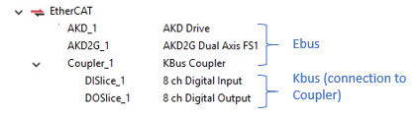 | Yes (Ethercat Network), slightly faster transmission time between I/O point and PxMM. Example  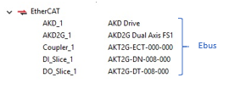
Coupler Sizing Sheet |  | How Many Remote I/O AKT-ECT-000-000 Couplers are Required in an Application. | Kollmorgen | Coupler Sizing - AKT2G Remote IO | Kollmorgen
IDE Implementation |  | Online: Module scanning available  Offline: Add slices through pull down selection. Slices are in a parent/child relationship to the ECAT coupler  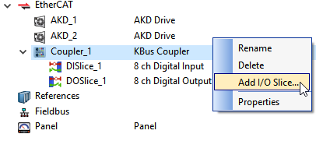  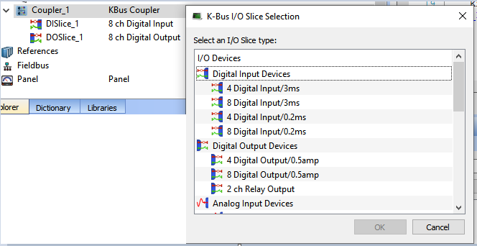 | Online: Module scanning available  Offline: Add slices through pull down selection from Ethercat Device Selector  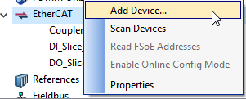
How shown in IDE project tree |  | Subset to Coupler, slices on secondary bus | Slices directly on the Ethercat bus
Adding other slices |  | No | Beckhoff E-bus slices can be added

More detail:
Remote Input/Output Terminals (kollmorgen.com)

