Project: AKD running a brush DC motor
Engineer: Dan Wolke
Date: 20JUN6

Material:
AKD-P00306-NBEC-0000, FW 1.14.0.3
PMDC Motor SR3642-4982-7-10-56BC-CU
AKM resolver motor used as feedback device

General notes:
- Without feedback, only torque mode can be used. AKD does not support “armature voltage feedback”
- Any feedback, that the AKD supports, can be used. (AKD does not support analog tach feedback)
- Most brush DC motors follow the GE positive rotation direction rule which is opposite of Kollmorgen AKM positive direction.
- Drive does not have advanced programming to prevent flash over during regen at high velocities. Low deceleration rates need to be used.
- Drive does not have a motor’s shunt field power supply output.
- Slider tuner and Autotuner will not work with brush DC motor. Typical brush DC motor’s system bandwidth is too low. System will need to be tuned using the scope and step response.
- AKD will limit the RMS max voltage to the motor but does not regulate the PWM peak voltage to the motor. The AC/DC supply to the AKD needs to match the motor’s insolation voltage rating. Example: 120VAC will put 165VDC peak to the motor. 230VAC will put 325VDC peak to the motor.
- Motor’s “line to line” inductance needs to be within the drive’s limits as described in the AKD installation manual.

Setup Procedure:
- Defaulting the drive is always a good starting point.
- On the motor page, change Motor Autoset to “off” and Motor Type to “Brush Rotary”

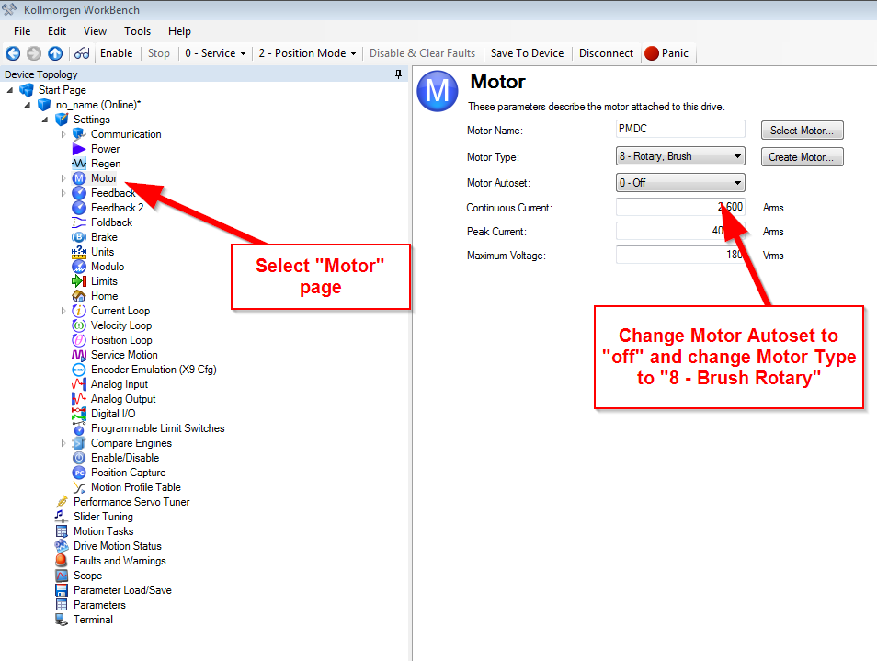

- Then fill out the rest of the motor page items.
- Switch to the Workbench Terminal page. Setup the rest of the motor’s parameters (I have asked that these parameters be added to the motor page so, in future Workbench revisions, you will not need to do this)

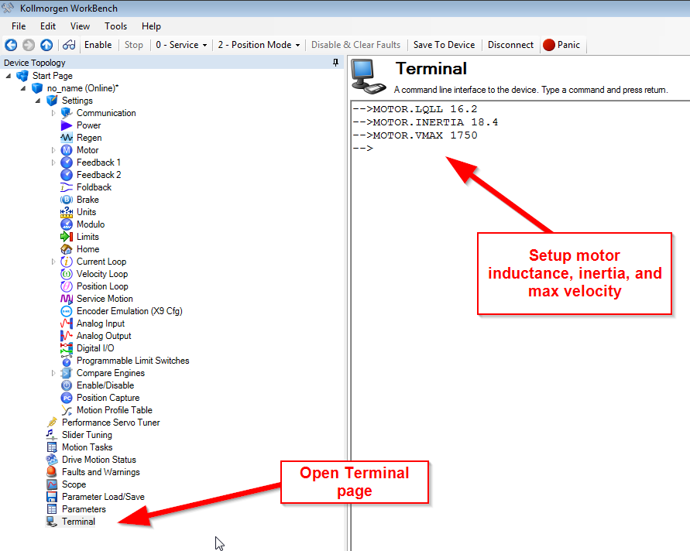

- Switch to the Current loop page. Using the known motor’s inductance, setup the current loop gain. Formula = MOTOR.LQLL x 2 x Pi = IL.KP. Example: My motor’s inductance = 16.2mH. 16.2 mH x 2 x Pi = 101.7

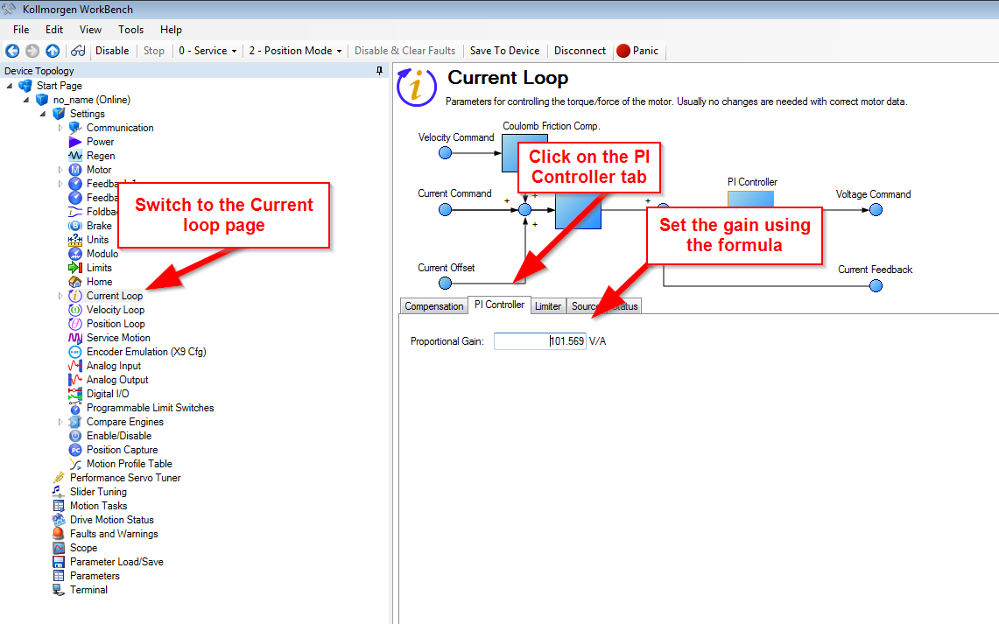

- Switch to the Limits page. Setup the motor’s velocity and ACC/DEC limits.

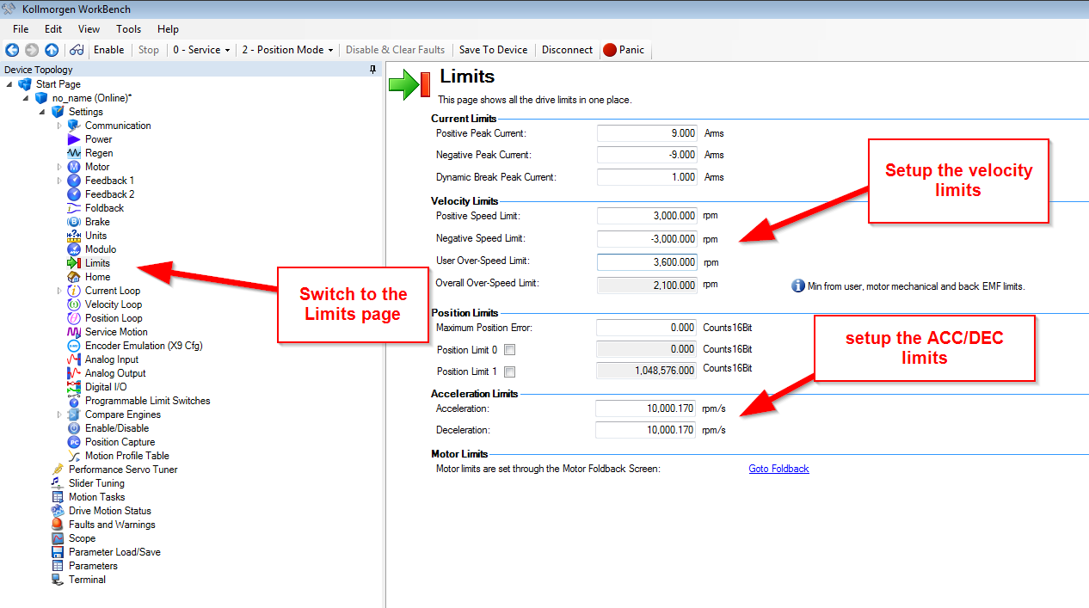

- Switch to the scope page. Make the following channel setup:

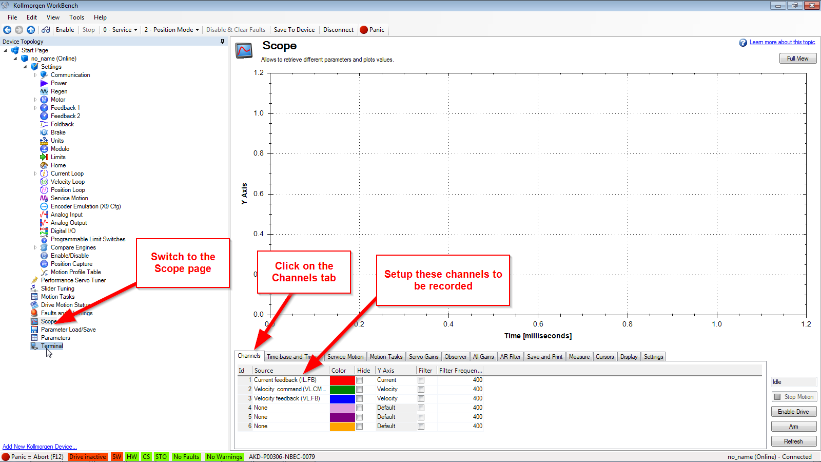

- Change to the Time-base and trigger tab. Make the following setup:

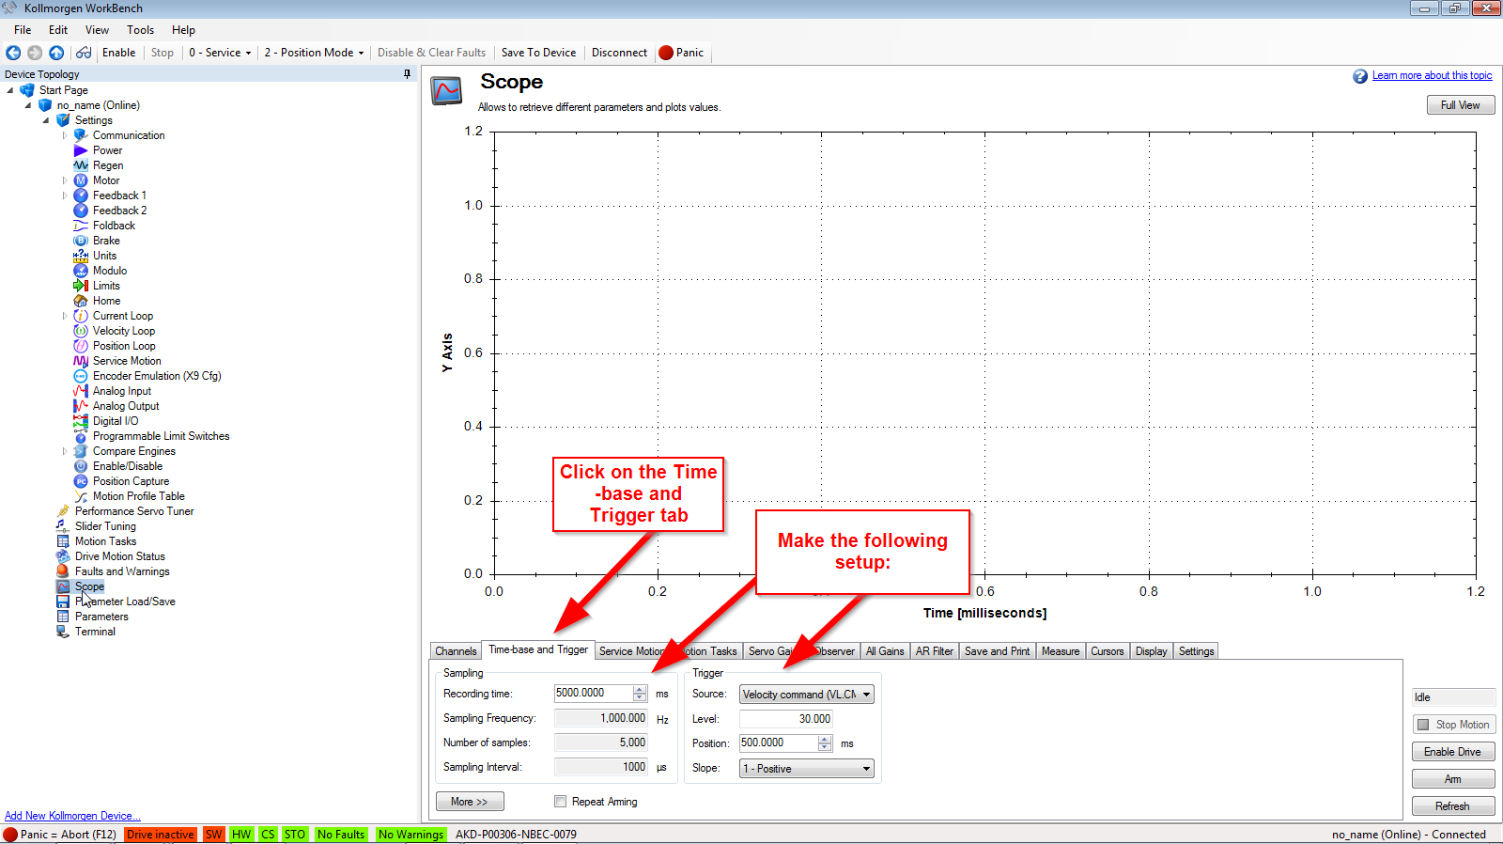

- Switch to the Service Motion tab. With the drive in torque mode, enable the drive and command enough current to move the motor. Check direction.

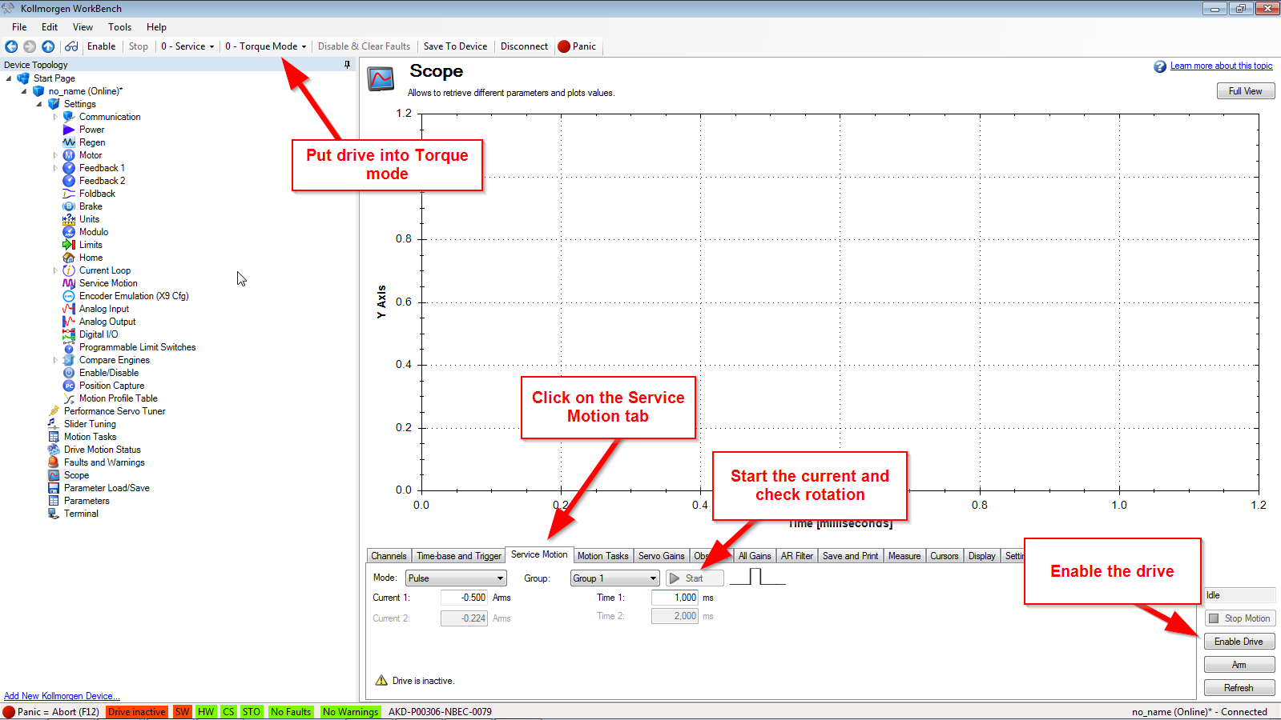

- Disable the drive, change the OpMode to Velocity or Position ( your option). Then setup the service motion to make a single step response. Remember, most brush DC motor has a 10:1 speed range. My motor’s max speed is 1750 so I need to setup the service motion velocity to at least 175 RPM to get a good reading. (In the case of my plot, my feedback is an AKM motor coupled to the PMDC motor. The coupling has a “bump” in its rotation. Shows up in my plot.

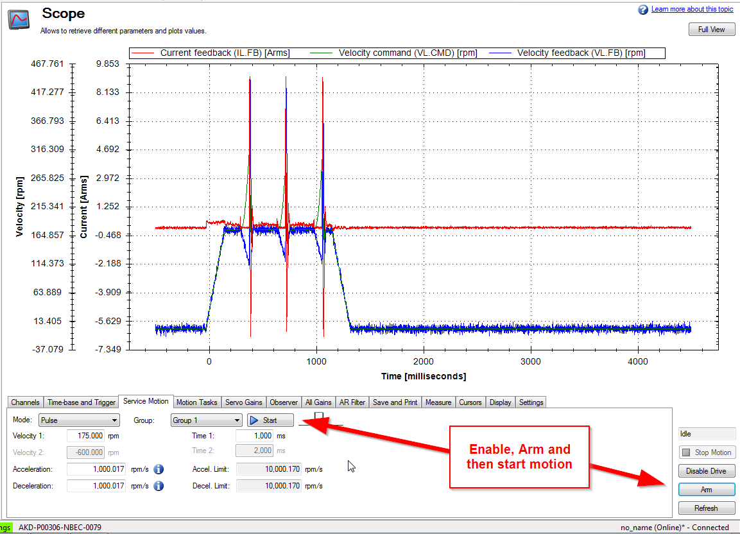

- Click on the Servo Gain and the AR Filter tabs and tune the system much like you would tune a typical servo. Please keep in mind the typical Brush DC Motor’s bandwidth is very low and you will see long settling times in your plots. Trying to reduce these long settling times could result in flash over of the motor’s commutator.

