

Exercise #3 KAS Integrated Development Environment
- KAS Motion
- Control Panel

Objective: Add additional motion to the project. A phase adjust function block will be added.

KAS supports two motion Engines
- PipeNetwork
- PLCopen
The PLCopen motion engine has been used in this project. Each Engine is supported by a set of function Blocks in the Library

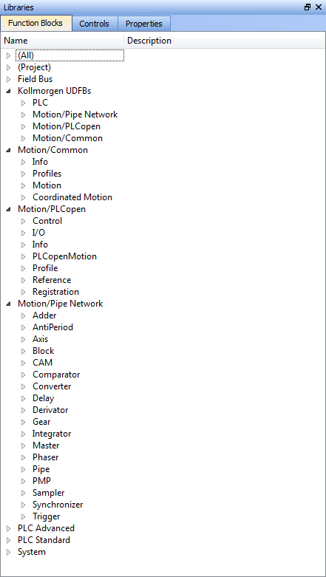
Pipe Network Motion Engine only
PLCopen Motion Engine only
BOTH Motion Engines (except Coord Motion - PLCopen Only)
Some for each Motion Engines

Help File Example
Go to the Library. Open: Motion/PLCopen. Then open PLCopen Motion. Then click on MC_MoveRelative. Click on the F1 key. This is one way to get to the contact sensitive help information.

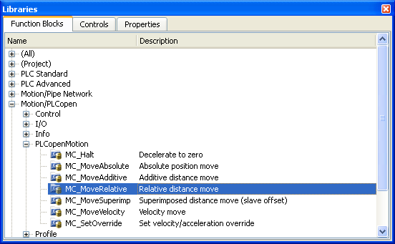 | 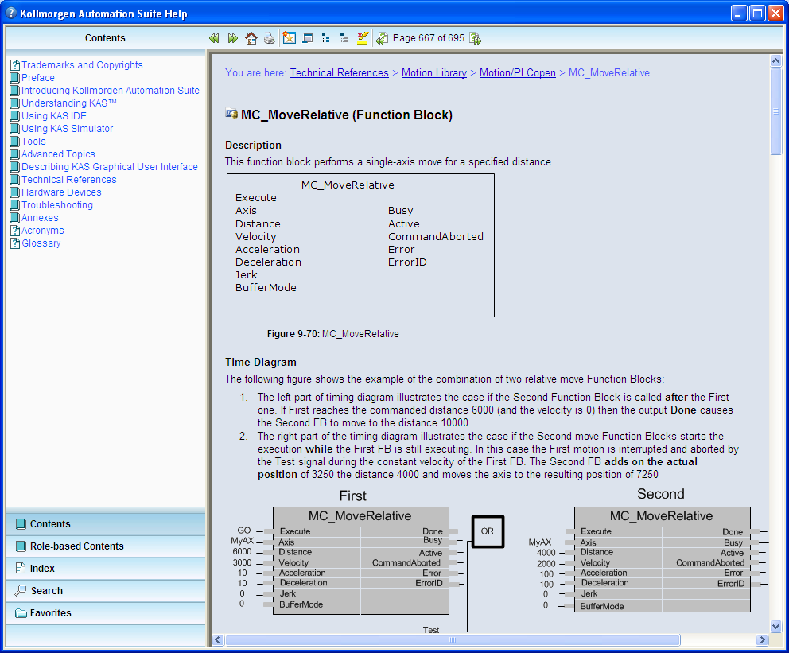

Adding phase adjust functionality
In the code there is two axes defined:
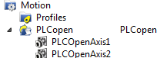

In the project, Axis 1 is the master and Axis 2 is the slave. The master/slave relationship is established using the MC_GearIn Function Block:

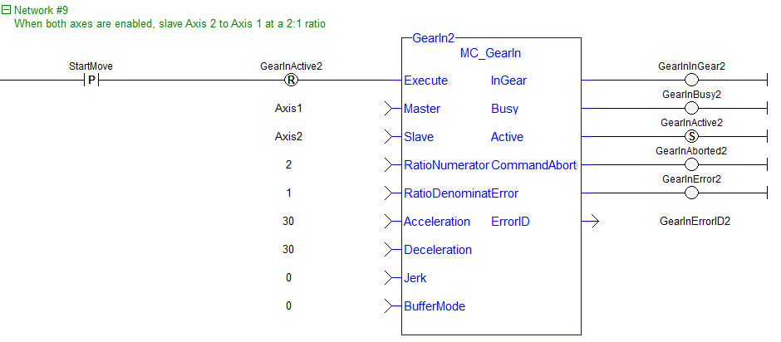

To accomplish a phase adjust move of Axis 2 a new Network will be added to the Main Program and controls will be added to the Control Panel
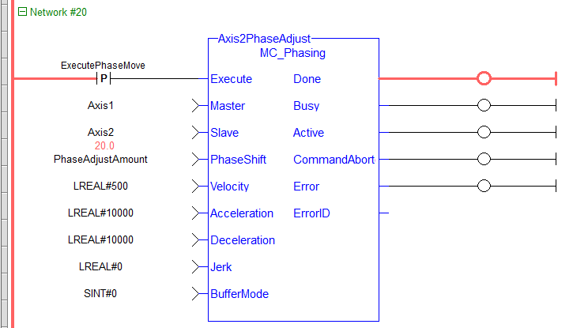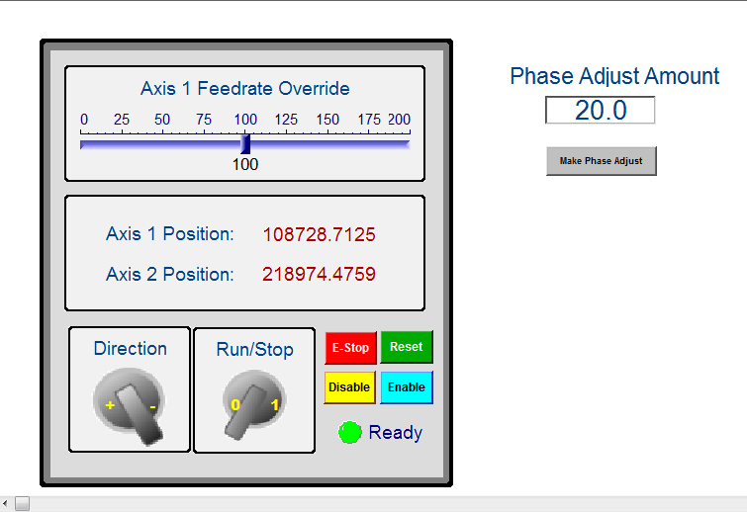

To add the new network, go to the bottom of Main program and insert a new Network and drag in a MC_Phasing function block.
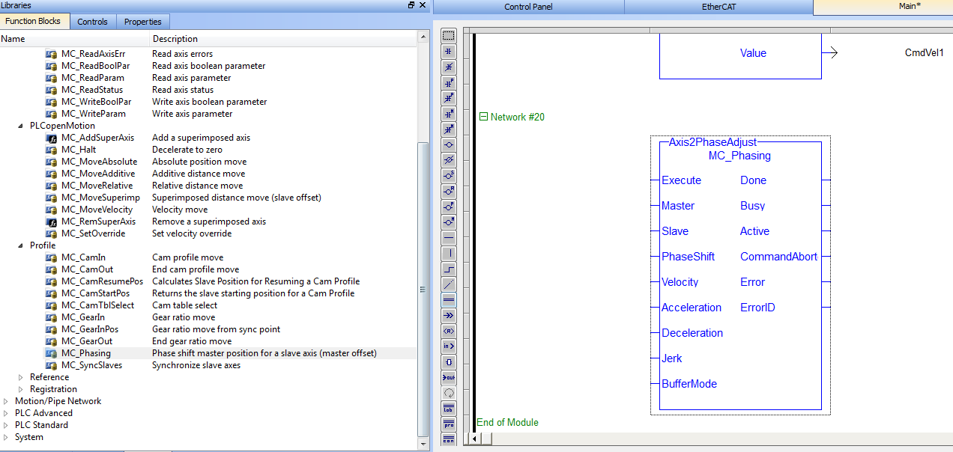

Assign it the name Axis2PhaseAdjust

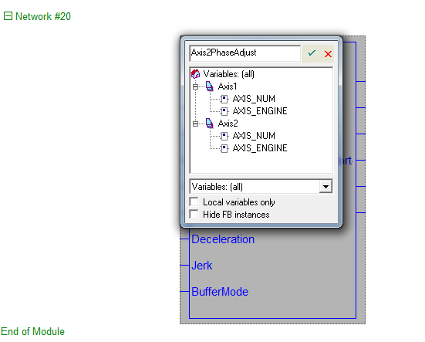

Leave the following at the default settings which will make it a local variable:

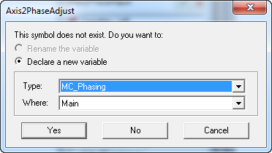

Next define the inputs and outputs as follow.

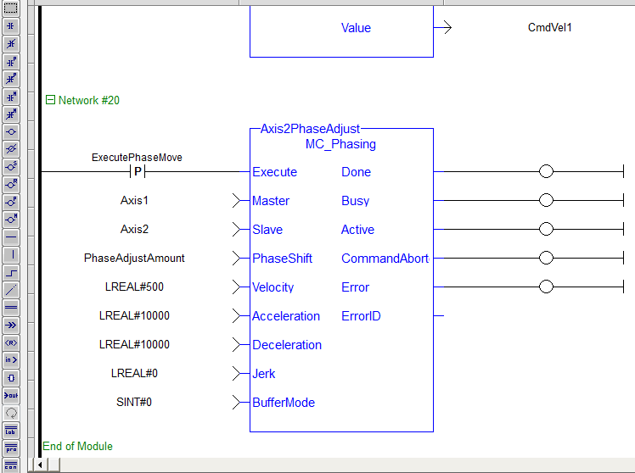

The Type for the added variables is as follows:

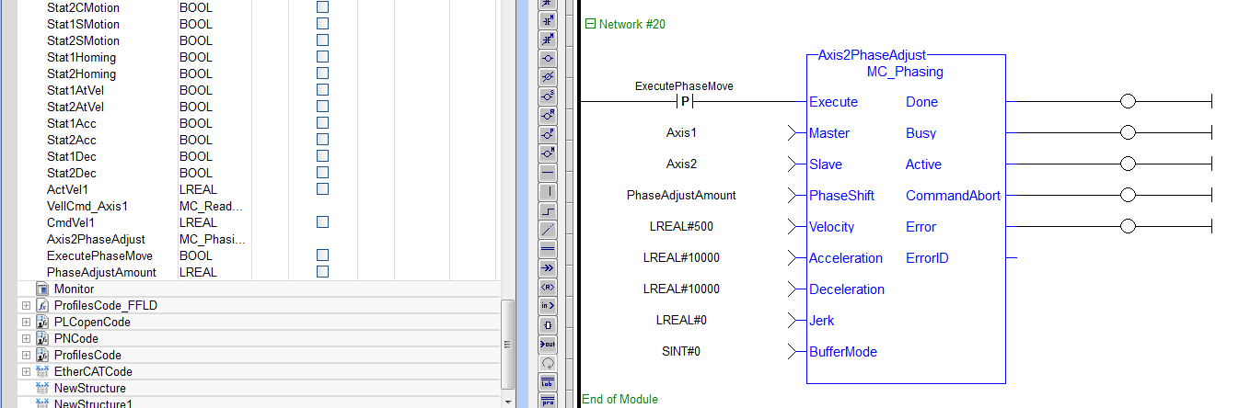

Add a control to the Control Panel to support the added phase adjust capabilities

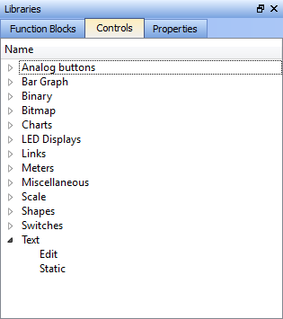

Three items will be added to the Control Panel:

- Header Description: Phase Adjust Axis2
- Box to enter the phase adjust amount
- Push button to execute the phase adjust
To add the Header go to the library and click on Controls. Open “Text” then click on ‘Static” Drag it to the place where the header will go on the control panel. The library tab automatically switches to Properties. Add the following:
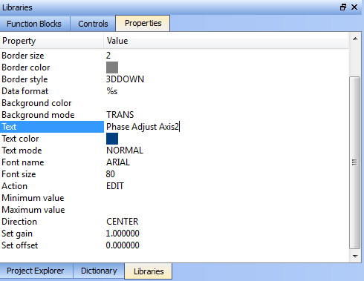

Then enlarge the box (by dragging the side) in the Control Panel to show all the text

To add the phase adjust amount go back to Library and this time insert a Text/Edit item. In the Properties window connect this control to the variable PhaseAdjustAmount by using the selection box format (double click in the box)
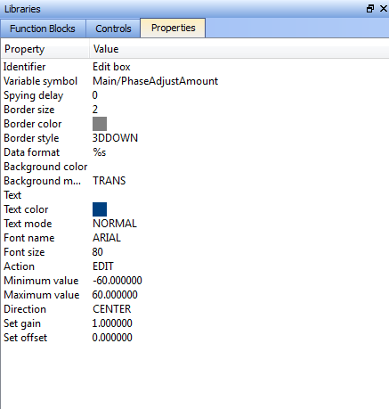

To add the Push Button go back to Library and this time insert a Switches/Push button. Tie the controls into the variable ExecutePhaseMove.

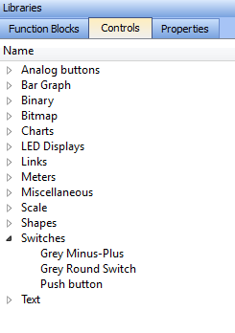
4. The control Panel should look similar to the following:
Added Section
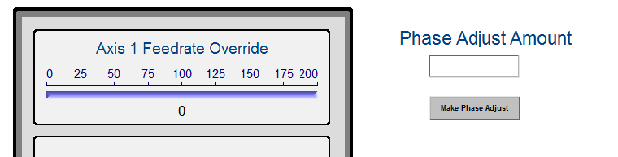

Run the Project
This program will now be run on the KAS simulator or 2 axis Demo.
- Click on the compile button to compile the program.
- Connect to the simulator or demo. Stop any program that is presently running.
- Then click on the download and start buttons to run the modified program

The Control Panel screen will now be used to demonstrate the phase change. After starting the program, as before, use the Control Panel to make the Axis2 phase correction. Try it with both positive and negative values.

Let’s make one final addition of setting limits on the amount of phase adjustment that can be made at one time. To do this go into the Properties window of the box in which the phase amount is entered and in the appropriate fields enter limits of -60 to 60.

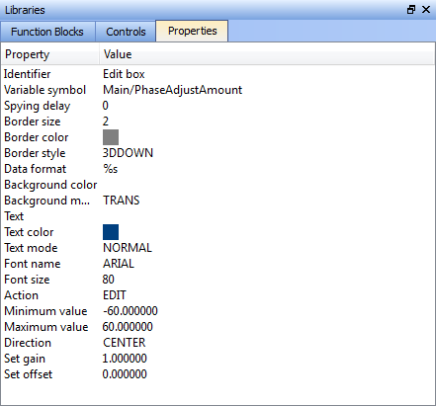

Then test the limits. Note: Since the Control Panel only operates in the IDE environment it is not necessary to compile the project to implement this change. Save the Project to your PC hard drive: IDE intro.kas.

